MSCD640
Lab 2_PDB

Name: Rohan Purohit

Date: Sept 20 2015

-----------------------------------------------------------------------------------

The purpose of this lab is to become familiar with the following types of basic DBA tasks:
- Managing users and basic security
- Creating and managing tables and constraints
- Creating and managing indexes
- Creating and managing views, synonyms, and sequences

Read Chapters 6 through 9 in the book before starting this lab.

These labs focus on how to perform DBA tasks from the SQL*Plus command prompt. These labs do not show how to perform tasks from Enterprise Manager. I prefer that students learn basic DBA tasks from SQL*Plus for the following reasons:
- Not all environments have Enterprise Manager installed, therefore you’ll need to know how to perform basic DBA tasks from the SQL command prompt.
- Performing the tasks manually from SQL gives you a better understanding of the underlying SQL used to accomplish DBA tasks.
- If you can perform DBA tasks from SQL, then you’ll have no problems understanding how to perform the same tasks in Enterprise Manager.

To get an “A” grade on this lab:
- Answer all questions.
- Provide output of all steps that require you to perform a task. The output can be a spool file, cut and paste from the screen to a word document, screen shots. I need to see something to verify that you ran the labs. I’m expecting you to turn in a word document that contains each question and also the corresponding answers to questions asked and output from SQL statements.
- Longer code required for labs can be found on the ORA05 database server under /home/mscd640/MSCD640_Scripts. If a script file is required to complete a lab exercise it will be noted in the exercise itself. Some exercises will require the student to type in a defined code snippet found in the lab exercise. If cutting and pasting code from the Lab document to a SQL session on the database server be sure to review pasted code for possible conversions of single quote marks (‘) to periods (.). If an undesired symbol conversion happens the student will need to correct the code prior to submitting the statement again. If, when submitting code, an SP error is returned, this indicates a syntax error typically due to a missing semi-colon, single-quote mark, or misspelled object name, identifier, variable, or clause.
-----------------------------------------------------------------------------------
Lab 2, Part 1: Users and Basic Security
Read Chapter 6 in the book.
----------------------------------------------------------------------------------

Before starting your labs, after logging into the Regis database server, cd to your student directory created in Lab1:

Ex: [mscd640@ora05 ~]$ cd <your student dir name>

1. Logon to your pluggable database with your admin username and password. If your database is not open proceed to open it by following the steps below. If your database is already opened, note its’ status and go to exercise #2.

- Logon to the parent container database as sysdba;
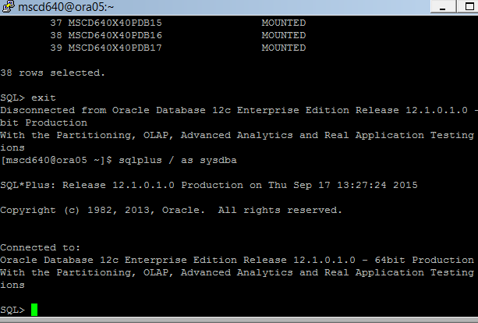
We will be logging onto the parent (ROOT) container.

Ex: [mscd640@ora05 ~]$ sqlplus / as sysdba

b) Show the name of the container database you are sitting in. You should be returned the value of CDB$ROOT:

Ex: SQL> show con_name
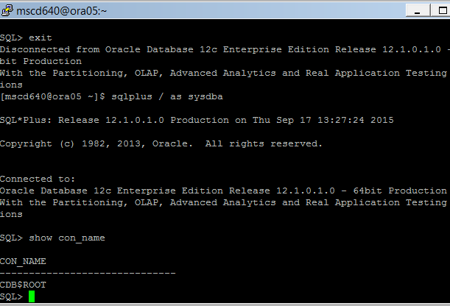

c) Show the name and open status for just your pluggable database:

Enter your pluggable database name in CAPS
Ex: SQL> select con_id, name,open_mode
from v$pdbs
where name = ‘your pluggable database name in CAPS’;
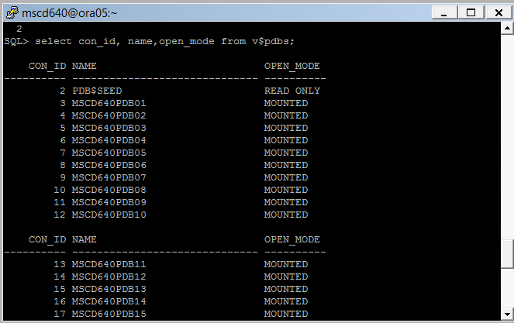

d) If your database is in a MOUNT state perform the following two steps:

- Open your pluggable database.

Replace the ‘xx’ in the example below with your pluggable database number.
Ex: SQL> alter pluggable database msc640xpdbxx open;

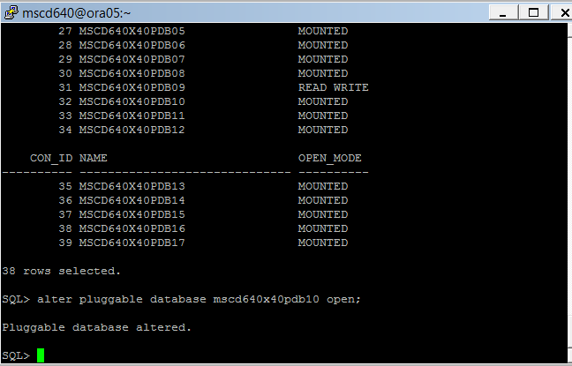

- Show the name and open status for just your pluggable database:

Enter your pluggable database name in UPPERCASE
Ex: SQL> select con_id, name,open_mode
from v$pdbs
where name = ‘your pluggable database name in UPPERCASE’;
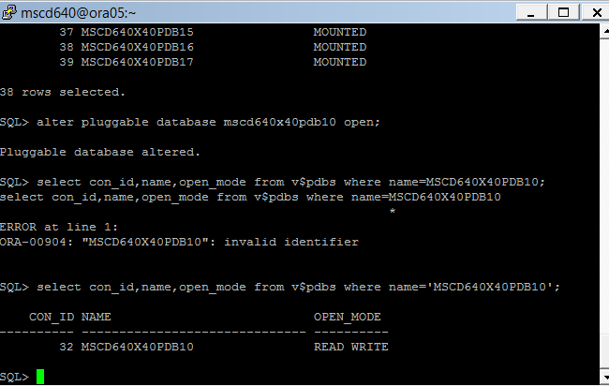

- Exit SQLPlus and verify you can log on to your pluggable database using your adminxx user account.

Replace the xx in the example admin username/password xpdb number with your assigned instance.
Ex: [mscd640@ora05 ~]$ sqlplus adminxx/adminxx@msc640xpdbxx
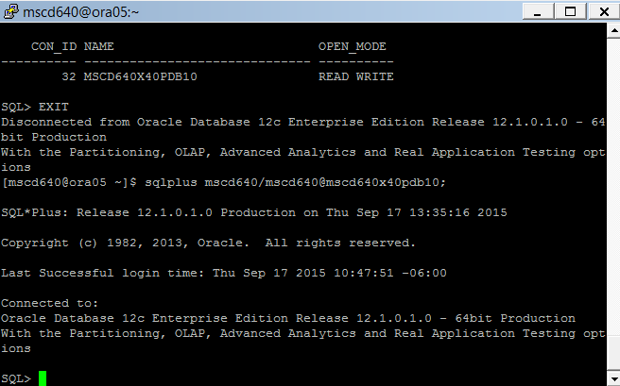
- Exit SQLPlus.
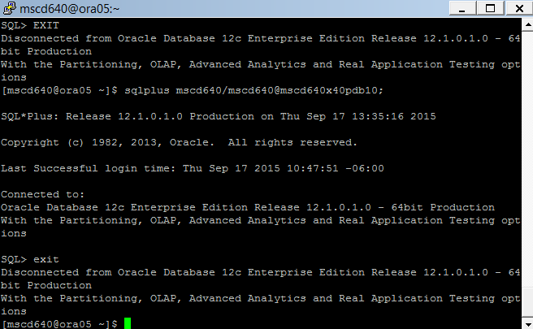
-----------------------------------------------------------------------------------

Before continuing with the lab2 read through the distributed powerpoint presentation, “Oracle 12c: Multitenant Databases Understanding Users, Roles and Privileges”, in the Week 4 Forum - Lab 2 Discussion Thread.

2. Using SQLPlus, logon to the root container as sysdba. Note that your PDB is not referenced in the logon command.

- Ex: [mscd640@ora05 ~]$ sqlplus / as sysdba
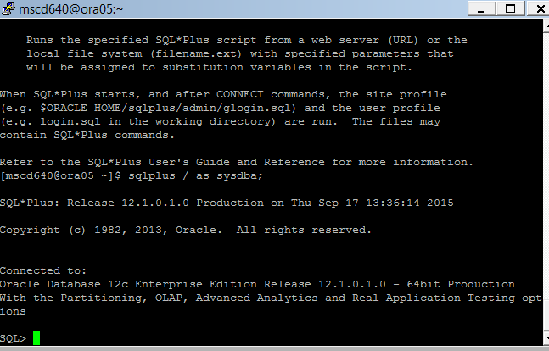
- Confirm the current container is the root container. The output should display CDB$ROOT.

Ex: SQL> show con_name
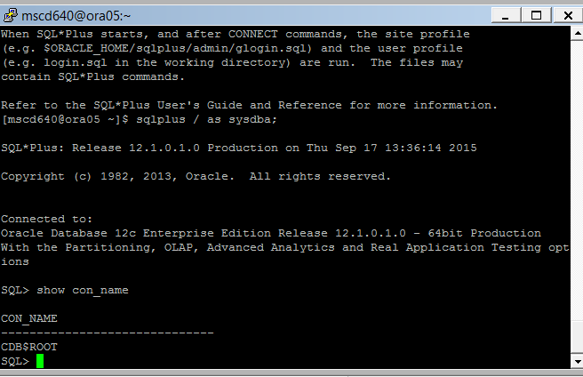

- Confirm the current container id is set to 1.

Ex: SQL> show con_id

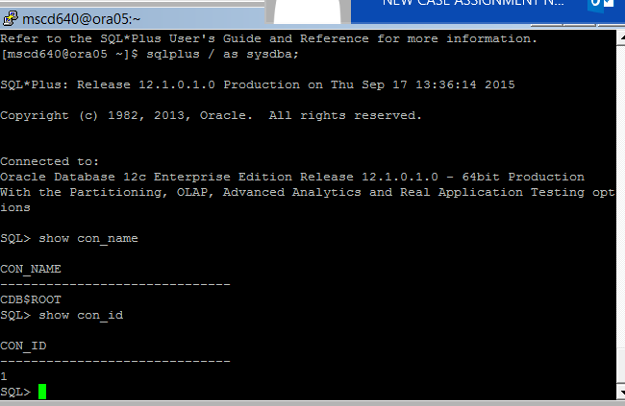
----------------------------------------------------------------------------------------------------------------------------------------------

3. Run the following SQL Script found in the $HOME/MSCD640_Scripts directory in your SQLPlus session. The output will display the number of SYS and SYSTEM accounts created in the multitenant database:

- Ex: SQL> @$HOME/MSCD640_Scripts/LAB2_Ex3.sql
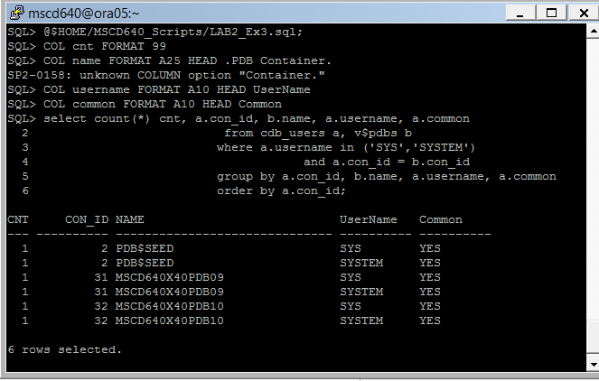
You should see one SYS and one SYSTEM account for each pluggable database container built in the database system. Based on the powerpoint presentation and your readings:

- How where the SYS and SYSTEM accounts created?

- Why are the SYS and SYSTEM accounts all defined as COMMON accounts?

-------------------------------------------------------------------------------------------------------------------------------------------
4. What are the differences between the SYS and SYSTEM users in an Oracle database?

-------------------------------------------------------------------------------------------------------------------------------------------

5. Issue the following SQL statement to determine how many users are created in the CDB and all PDB databases.

- Run the following SQL script to display a count of all local and common users in all databases (CDB root and local levels).
Ex: SQL> @$HOME/MSCD640_Scripts/LAB2_Ex5_1.sql
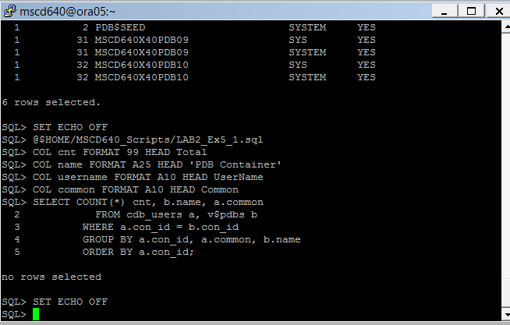

- Run the following SQL Script to display the dba users created in all databases?
Ex: SQL>@$HOME/MSCD640_Scripts/LAB2_Ex5_2.sql
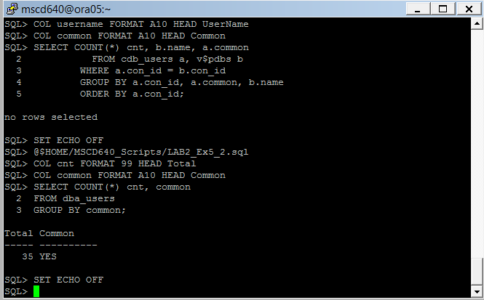
- What does the column COMMON indicate?

-----------------------------------------------------------------------------------------------------------------------------------

6. Select the users from cdb_users view that are associated only with your pluggable database.

- Alter your session to connect to your PDB container as SYSDBA.
Replace the red xx in the example with your pluggable database number.
Ex: SQL> alter session set container = msc640xpdbxx;
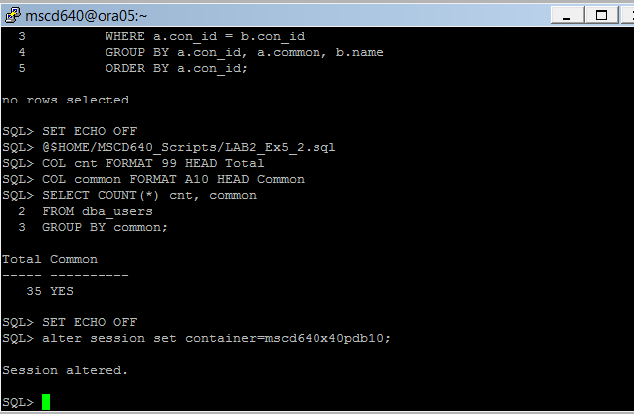
- Show your container name. The output should display your PDB name.
Ex: SQL> show con_name
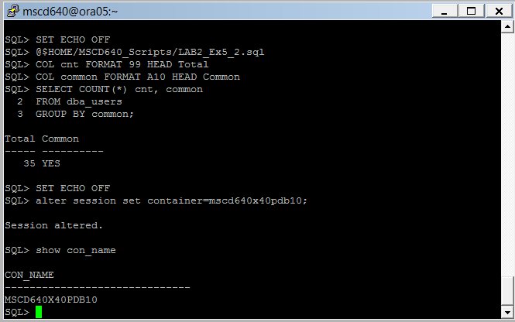

- Show the session user. The returned value should be SYS.
Ex: SQL> show user
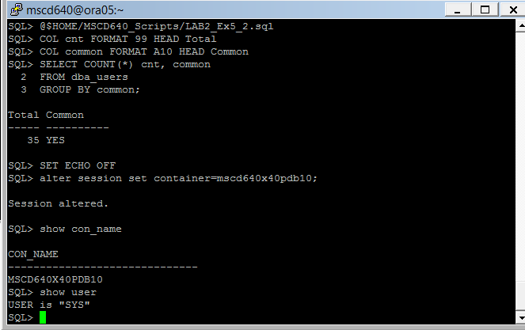
- Run the following script to display the users associated with your PDB.
Ex: SQL> @$HOME/MSCD640_Scripts/LAB2_Ex6.sql
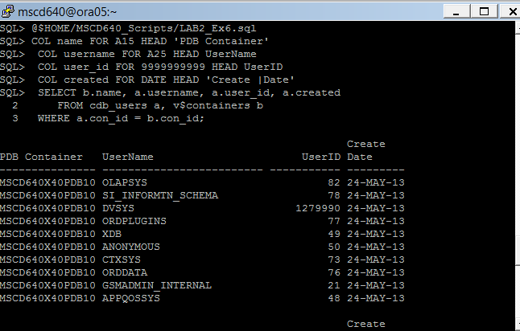
- Why is there a difference in the number of users between exercise 5.a and exercise 6.d?

--------------------------------------------------------------------------------------------------------------------------------------

7. Create a new user in your database. Assign the USER tablespace created in LAB1 as the default tablespace for the new user.

- Grant your ADMIN user SYSDBA privileges to continue DBA administration work.
Replace the xx in the example with your pluggable database number.
Ex: SQL> grant sysdba to adminxx;
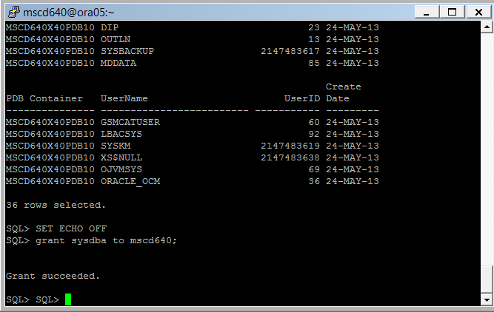

- From the SQL prompt, connect to your pluggable database as your ADMIN user.
Replace the xx in the example with your pluggable database number
Ex: SQL> conn adminxx/adminxx@msc640xpdbxx
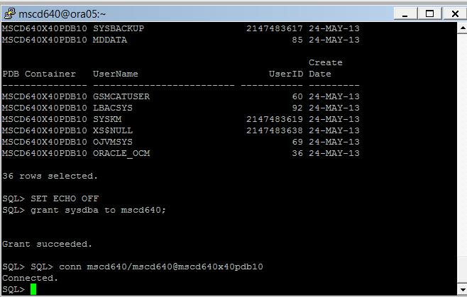
- Confirm you are still sitting in your PDB container before creating a new user. The output should display your PDB name.
Ex: SQL> show con_name
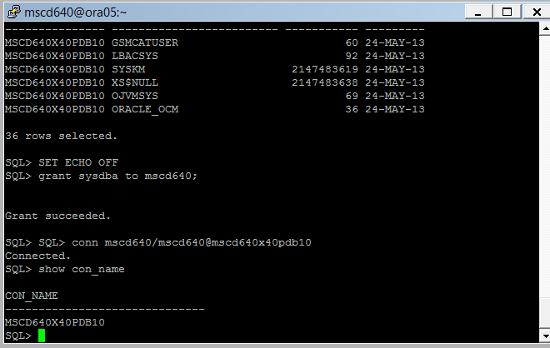
- Query for the default temp tablespace used by your user:

Ex: (replace the xx in the example with your admin user number. Uppercase the name of your user)
select temporary_tablespace
from cdb_users
where username = ‘ADMINxx’);
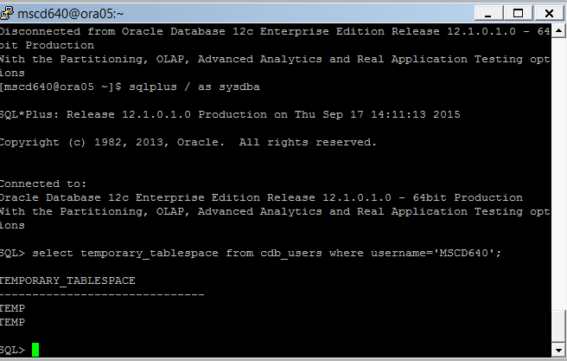
- Using the default temporary tablespace names found in (c) above, create the following new user:

Ex: SQL> create user heera identified by chaya
default tablespace users
temporary tablespace temp;

I was able to create heera by only specifying default tablespace as system.

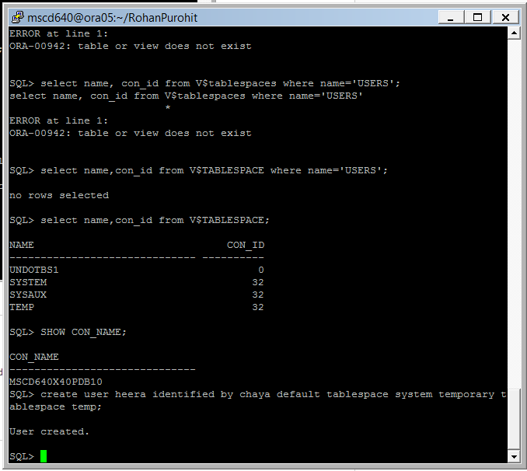
- Grant the appropriate privileges required to allow a user to connect to the database:
Ex: SQL> grant connect to heera;
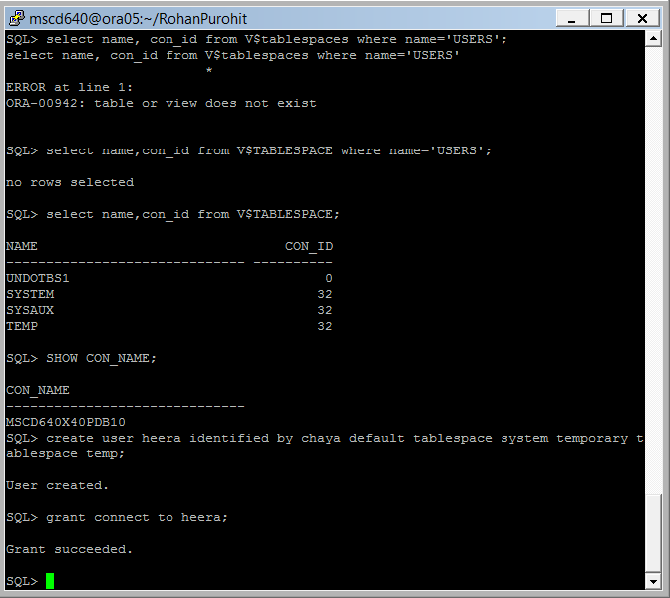
- Alter the user to expire the password for your new user:
Ex: SQL> alter user heera password expire;
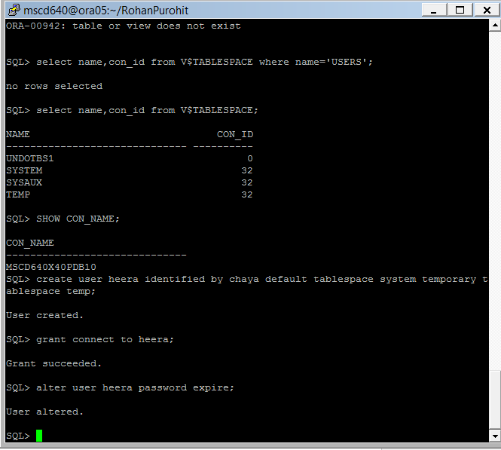
- Exit SQLPlus.

- From the server command line connect to your database as your new user
(replace the xx in the pdb name with your pdb number):
Ex: [mscd640@ora05]$ sqlplus heera/chaya@msc640xpdbxx
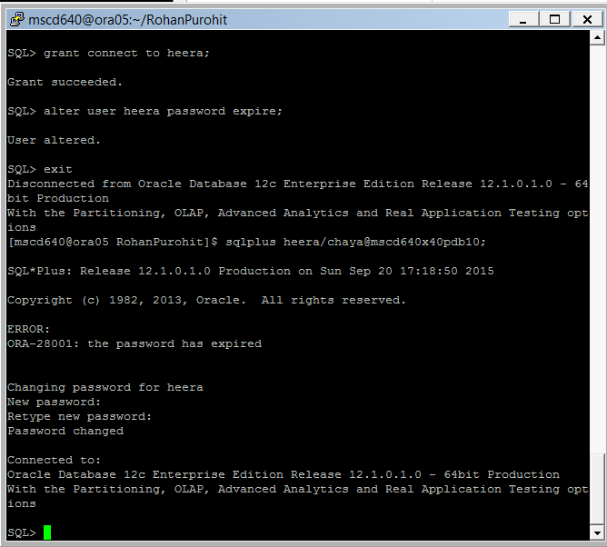
- What happened? I was prompted for new password.

- Change the password for heera at the request prompt.

- Why were you asked to change the user password? Because old password was set to expire by previous command.

- Show your connected user.
Ex: SQL> show user;
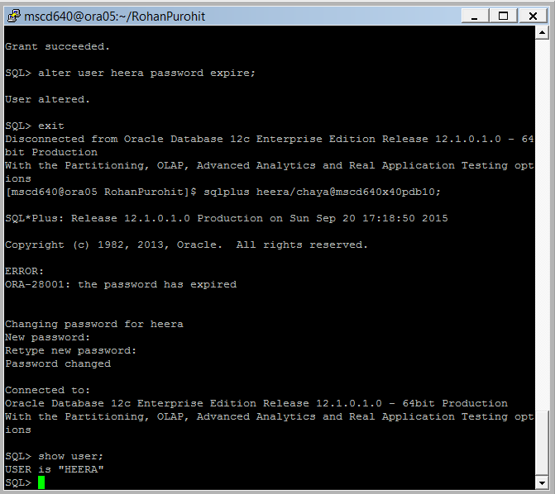
- Exit SQLPlus.

--------------------------------------------------------------------------------------------------------------------

9. Alter user HEERA’s password using your ADMIN account.

- Logon to your PDB using your admin user account.
(Replace the xx in the example admin username/password xpdb number with your assigned instance.)
Ex: [mscd640@ora05 ~]$ sqlplus adminxx/adminxx@msc640xpdbxx

- Issue the following alter user command defining a new password of your choice:
Ex: SQL> alter user HEERA identified by <your new password>;

- Run the following command from SQLPlus connecting as user HEERA using the new password created in step (b) above:
Ex: (replace the xx in the dbconnect name with your pluggable database number)
SQL> conn HEERA/<your new password>@msc640xpdbxx
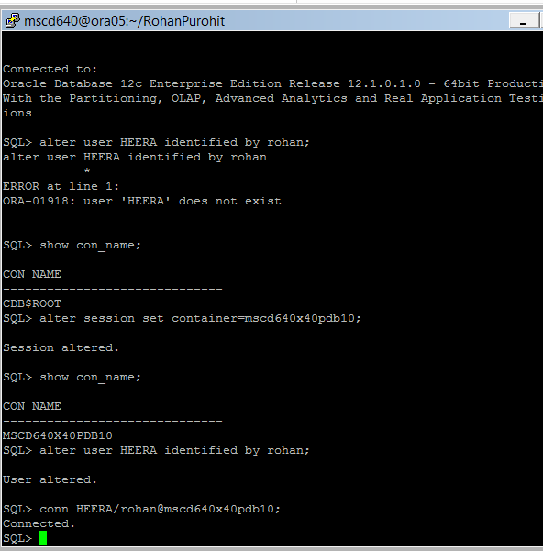
----------------------------------------------------------------------------------------------------------------------

10. Show the user, account locking status, and expiration date for your new user.
See page 127 in the book.

- From your current SQLPlus session, connect to your pluggable database using your admin account.
(replace the xx in the admin username, password, and database sid with your pluggable database number)
Ex: SQL> conn adminxx/adminxx@msc640xpdbxx

- Call the following SQL script to display the locking status for your new user Heera:
Ex: SQL> @$HOME/MSCD640_Scripts/LAB2_Ex10_b.sql
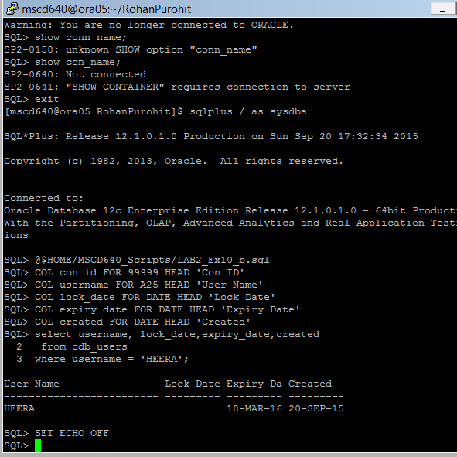
- What’s the difference between the LOCK_DATE and EXPIRY_DATE?
Locking a Password:
To temporarily deny access to the database for a particular user account, you can lock the user account. If the user then attempts to connect, then the database displays an error message and does not allow the connection. You can unlock the user account when you want to permit database access again for that user.
Expiring a User Password:
When you expire a user password, the user is prompted to change his or her password the next time that user logs in
-----------------------------------------------------------------------------------

11. Call the following SQL script to create a script file named Lock_Heera.sql in the directory you are sitting in on the server. The file created will contain a SQL ALTER USER statement to lock user HEERA’s user account. The ALTER statement written to the file will be also be displayed in SQL Plus.

- Ex: SQL> @$HOME/MSCD640_Scripts/LAB2_Ex11_a.sql
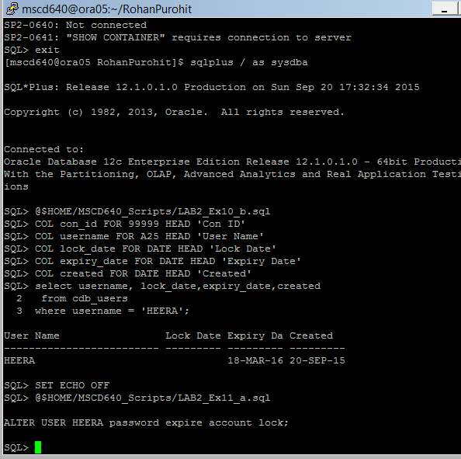
- Run the script file created from SQL Plus to lock user Heera’s user account.
Ex: SQL> @lock_Heera.sql

- Verify that the account has been locked:
Ex: SQL>@$HOME/MSCD640_Scripts/LAB2_Ex11_c.sql
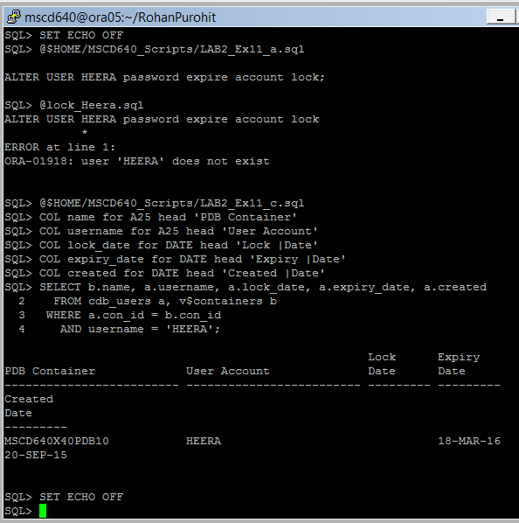
-------------------------------------------------------------------------------------------------------------------------

12. Which accounts in your PDB have never had the password changed?

- From your current admin SQLPlus session connect to the root container as sysdba.

Ex: SQL> conn / as sysdba;

- Show the container name. You should be sitting in the CDB$ROOT container.

Ex: SQL> show con_name
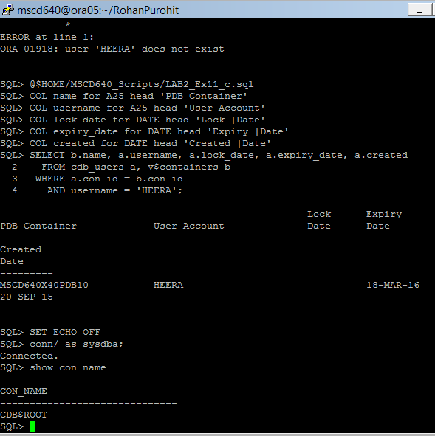

- We need to alter the current session container reference from the ROOT container to our pluggable database container so we can use the ROOT SYS account privileges to perform work on your pluggable database container.

Replace the xx with your pluggable database number.
Ex: SQL> alter session set container = msc640xpdbxx;

- Display the container name (should display your container name):
Ex: SQL> show con_name

- Show the current user (should display SYS):
Ex: SQL> show user

- Select a count of user records in the SYS view user$:
Ex: SQL> select count(*) from user$;
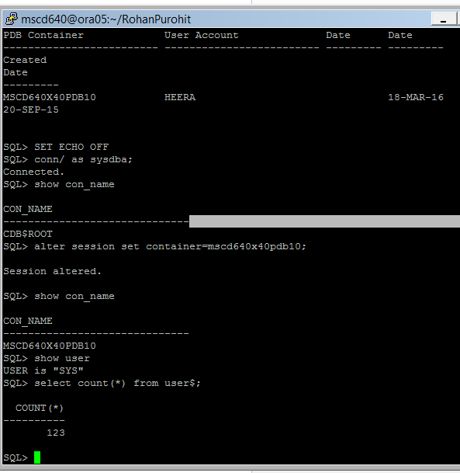

- Select a count of user records in the cdb_users view:
Ex: SQL> select count(*) from cdb_users;
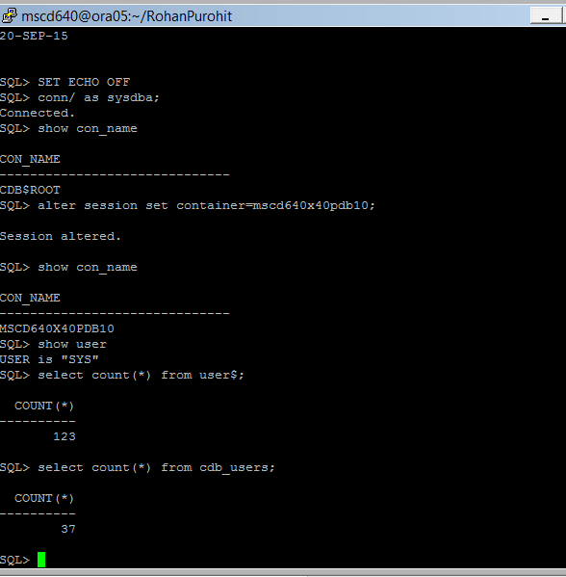
- Why does the user$ view have a larger number of users defined than the cdb_users view?
The user$ view is for larger record as it includes total users across all instances, cdb_users is just for the root.
- Run the following script from SQL to query the user$ and display the last time passwords were changed and the date passwords where created for users on the system:

Ex: SQL>@$HOME/MSCD640_Scripts/LAB2_Ex11_i.sql
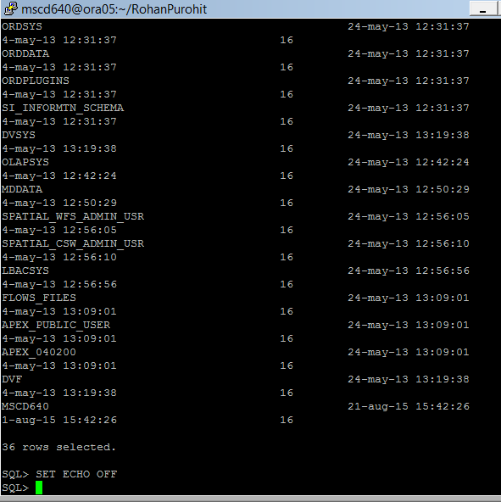
-----------------------------------------------------------------------------------

13. As with a non-multitenant database, varying levels of password verification can be defined. The ability to utilize password verify complexity is available in a dba profile which is loaded to the 12c database container via the UTLPWDMG.sql. You should still be connected as SYS with your pluggable database container referenced as set in exercise 12.

- Display the container name (should display your container name):
SQL> show con_name

- Show the current user (should display SYS):
SQL> show user
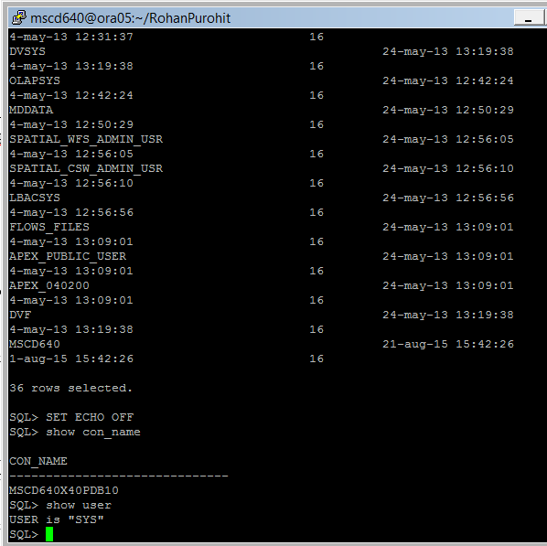
- Run the following query from SQL to view the default dba_profiles available. Look for the resource name of “PASSWORD_VERIFY_FUNCTION”. Note the Resource and Limit associated with the resource name.
Ex: SQL>@$HOME/MSCD640_Scripts/LAB2_Ex13_c.sql
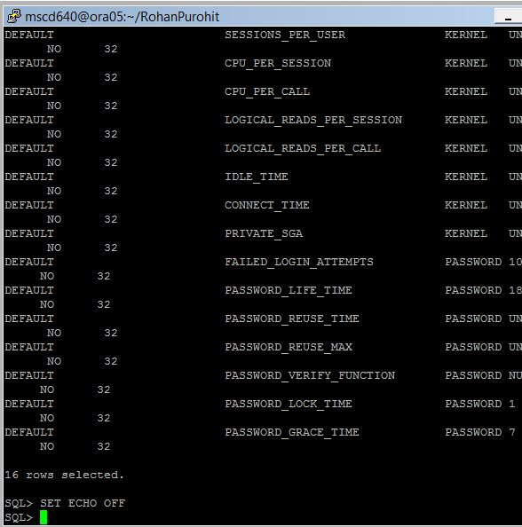
- From within your current session, run utlpwdmg.sql script for your PDB. Be patient, it may take a few minutes to complete.
Ex: SQL> @/640/oracle/product/12.1.0/dbhome_1/rdbms/admin/utlpwdmg.sql
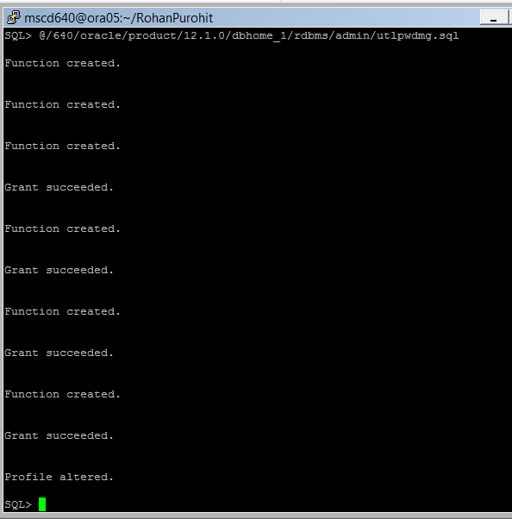
- Commit your changes:
Ex: SQL> commit;
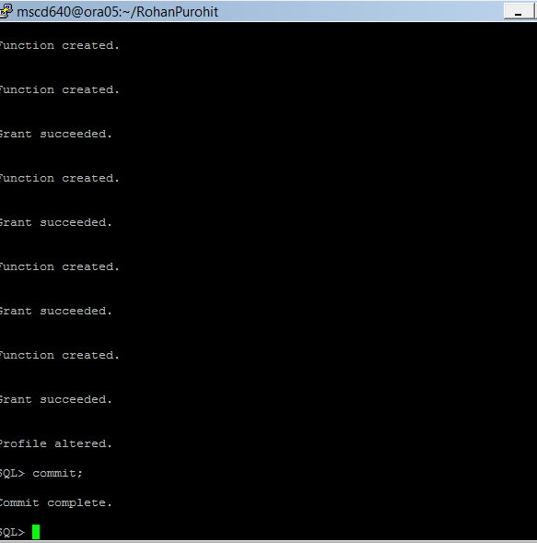
------------------------------------------------------------------------------------------------------------------------------
14. Now you will alter the default profile for your PDB to use the ora12c_verify_function password function to create a stricter password requirement.

- SQL> alter profile default limit PASSWORD_VERIFY_FUNCTION ora12c_verify_function;
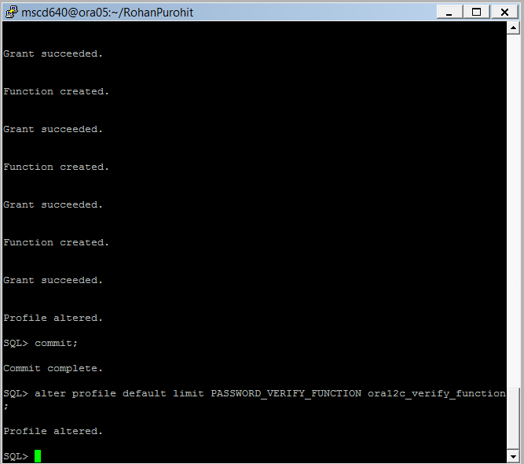
- Verify your changes by running LAB2_Ex13_c.sql again:
Ex: SQL>@$HOME/MSCD640_Scripts/LAB2_Ex13_c.sql

Note that the limit for the Resource PASSWORD_VERIFY_FUNCTION has changed to ORA12C_VERIFY_FUNCTION.
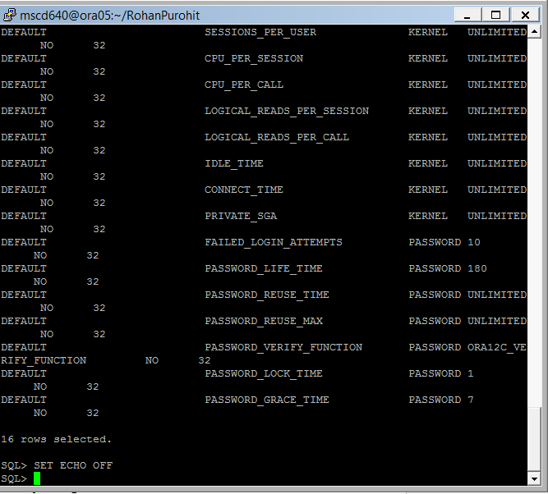
- Exit SQLPlus
-----------------------------------------------------------------------------------

15. Attempt to alter the HEERA user’s password.

- Logon to your pluggable database using your admin username and password:

Replace the xx in the example admin username/password and xpdb number with your assigned instance.
Ex: [mscd640@ora05 ~]$ sqlplus adminxx/adminxx@msc640xpdbxx

- SQL> alter user heera identified by foo;

- What happened in exercise 14 that is preventing user HEERA’s password to be changed to foo? We used oracles password verify function and changed how passwords could be updated.
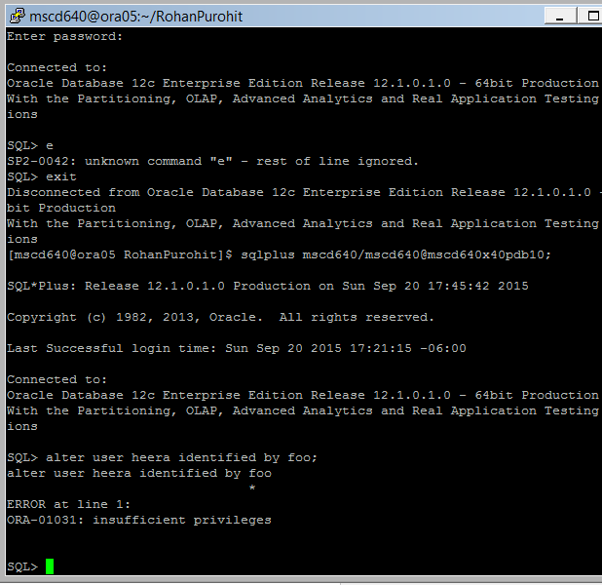
- Exit SQLPlus

-----------------------------------------------------------------------------------

16. Disable the password verify function for the default profile for your PDB by setting it to null:
See page 145 in your book.

- Logon to the ROOT container as sysdba.

[mscd640@ora05 admin]$ sqlplus / as sysdba

- We need to be logged onto the SYS account with ROOT SYS permissions and attached to our pluggable database container.
Alter the current session from the ROOT container to your pluggable database container:

Replace the xx with your pluggable database number.
SQL> alter session set container = msc640xpdbxx

- Display the container name (should display your container name):
SQL> show con_name

- Show the current user (should display SYS):
SQL> show user

- Disable the PASSWORD_VERIFY_FUNCTION.
SQL> alter profile default limit PASSWORD_VERIFY_FUNCTION null;
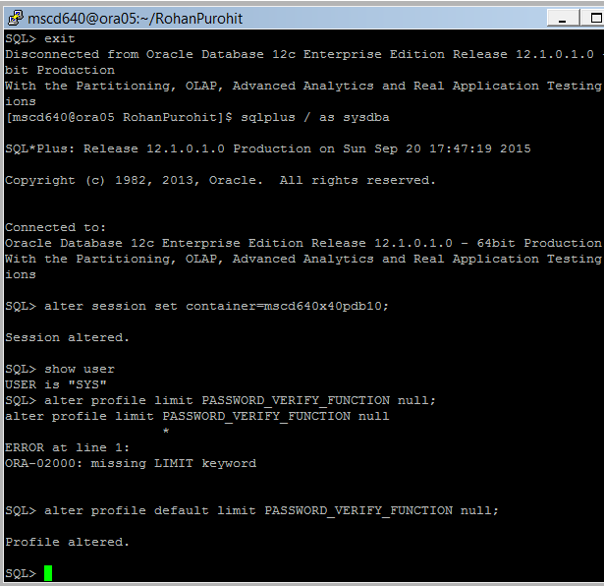
- Commit your changes:
SQL> commit;
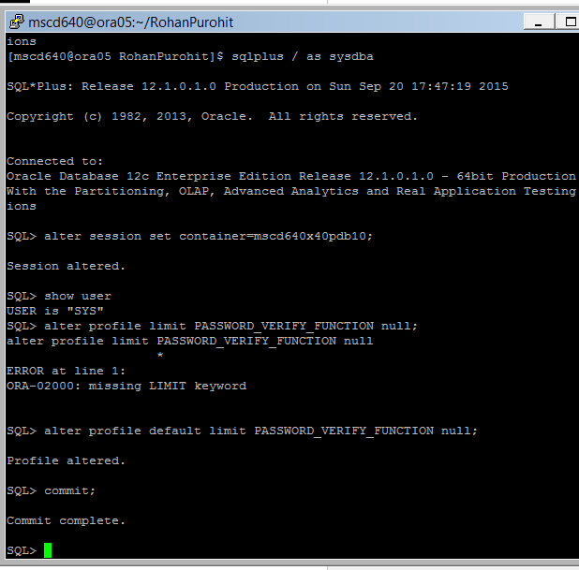
- Verify your changes by running LAB2_Ex13_c.sql again:
Ex: SQL>@$HOME/MSCD640_Scripts/LAB2_Ex13_c.sql
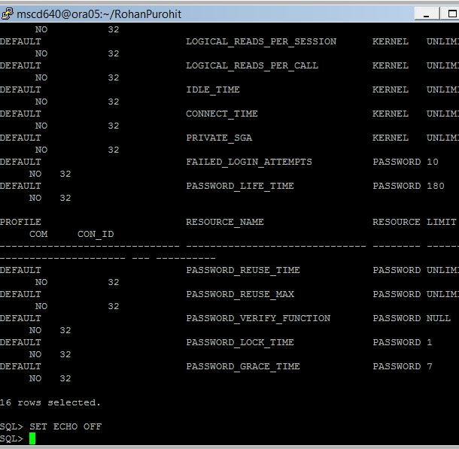
- Exit SQLPlus

-----------------------------------------------------------------------------------
17. Now can you modify user HEERA password to something not entirely secure:
- Logon to your pluggable database as your admin user.

Replace the xx in the example admin username/password and xpdb number with your assigned instance.
Ex: [mscd640@ora05 ~]$ sqlplus adminxx/adminxx@msc640xpdbxx

- Alter user heera’s password.

SQL> alter user heera identified by foo;
. 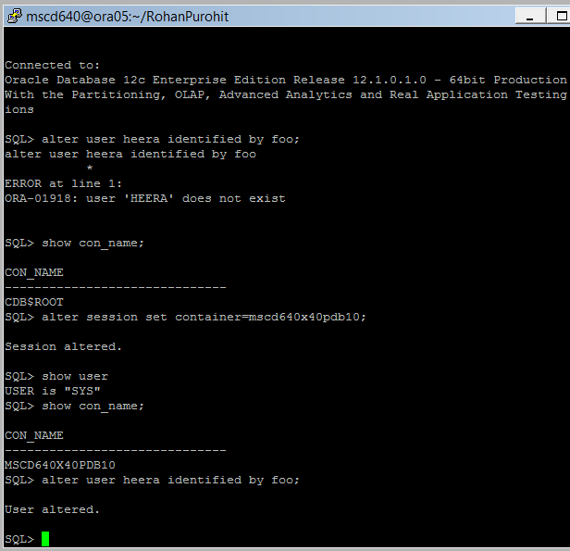
-----------------------------------------------------------------------------------

18. Lock and drop the HEERA account:

- SQL> alter user heera account lock;
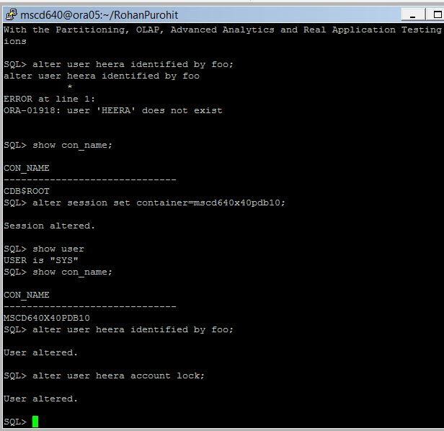
- SQL> drop user heera cascade;
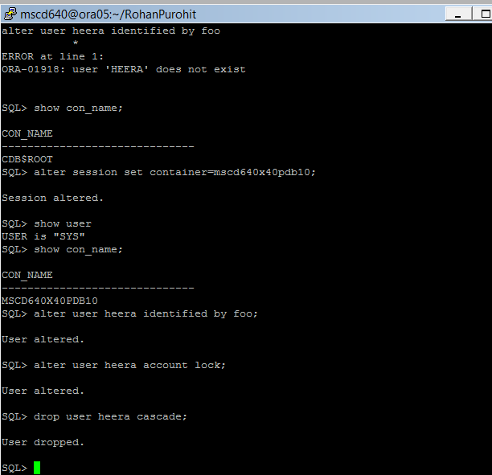
- Verify user heera is dropped from your PDB:
Ex: SQL> select count(*) from cdb_users where username = ‘HEERA’;
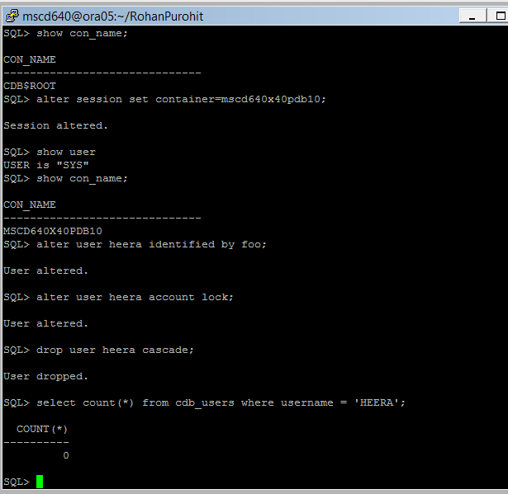

- What is the purpose of locking an account before it is dropped?
We do lock so that the password for that user cannot be changed.
-----------------------------------------------------------------------------------
19. What is the purpose of a database profile?
See page 141 in the book.
.
A database profile is an object assigned to a user that enforces password security and that constrains database resource usage.

20. What is the purpose of a SQL profile?
A SQL profile is associated with a SQL statement and contains corrections to statistics that help the optimizer generatea more efficient execution plan.
--------------------------------------------------------------------------------------------------------------------------
21. Create a somewhat secure database profile.
See pages 143 through 147 in the book.

Ex: SQL> create profile secure_app
limit
password_life_time 200
password_grace_time 10
password_reuse_time 1
password_reuse_max 1
failed_login_attempts 3
password_lock_time 1
password_verify_function verify_function_11G;
commit;
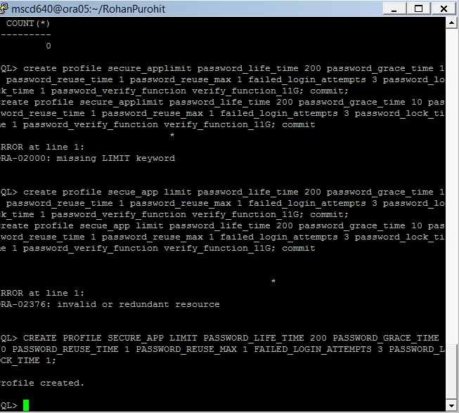
---- 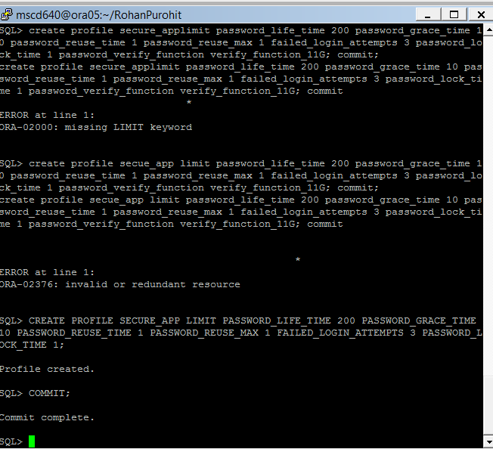 ----------------------------------------------------------------------------------------------------------------------

22. Create a user named APP_USER and grant the user CONNECT:

- Ex: SQL> create user app_user identified by foo
default tablespace users
temporary tablespace temp;

- Ex: SQL> grant connect to app_user;
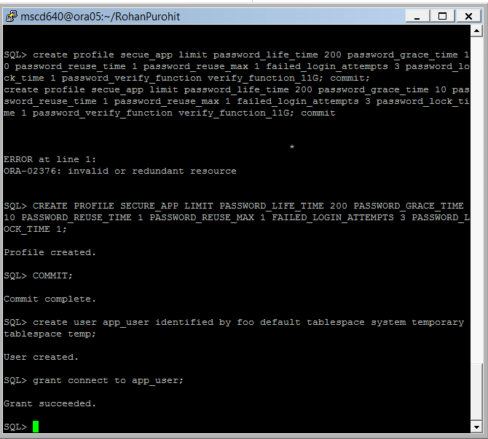
-----------------------------------------------------------------------------------
23. Assign the SECURE_APP profile created in exercise 21 to APP_USER:

Ex: SQL> alter user app_user profile secure_app;
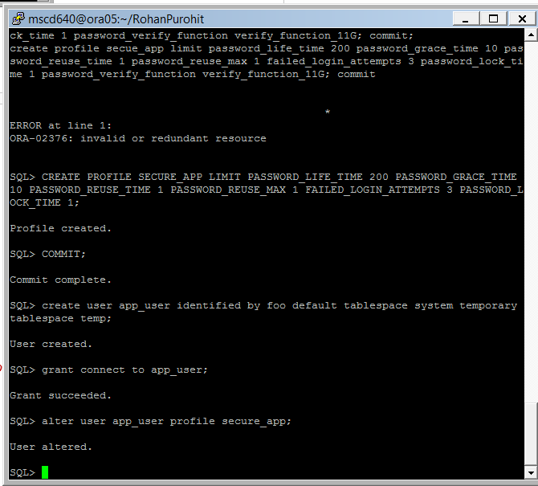
-----------------------------------------------------------------------------------
24. Attempt to change the APP_USER password:

- Ex: SQL> alter user app_user identified by foofoo;
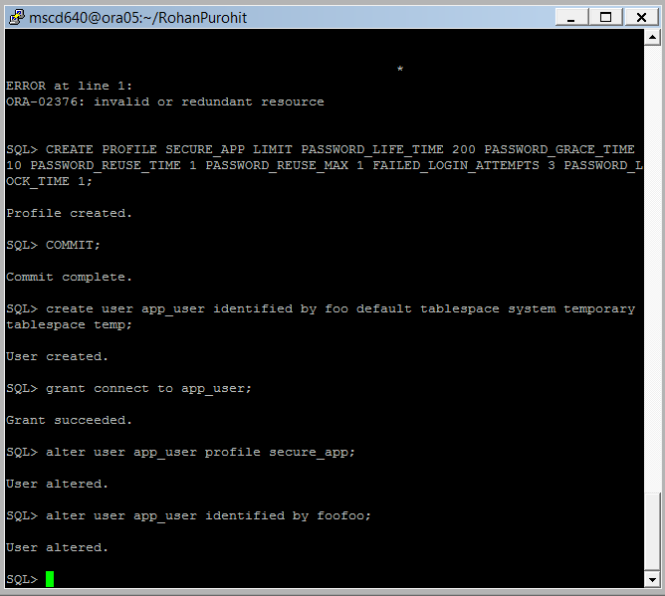
- What happens?
I was able to alter password.
- Try a more secure password:
Ex: SQL> alter user app_user identified by f00f00f0; ← zeros, not capital O
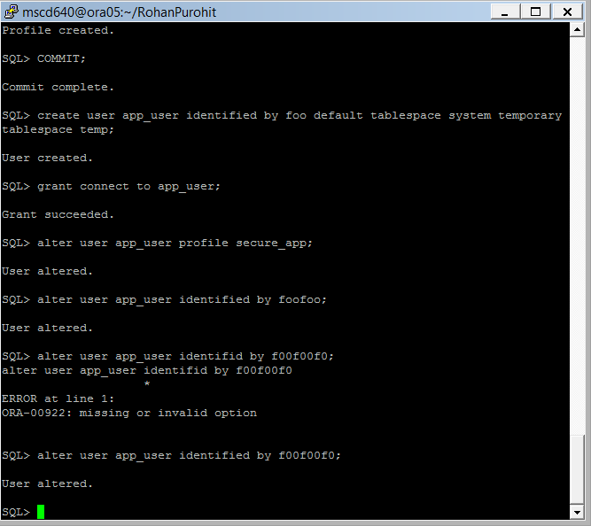
- Commit your updates:
Ex: SQL> commit;
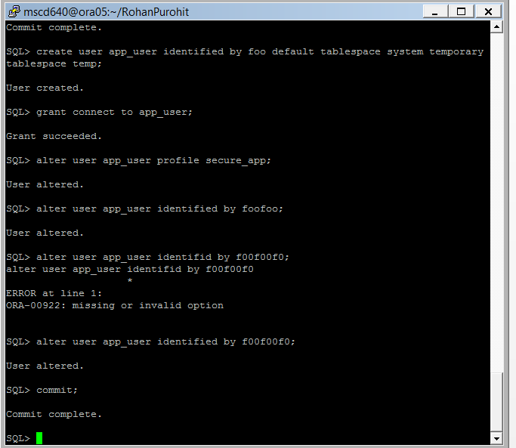
-----------------------------------------------------------------------------------

25. Enable your database to be able to constrain resources via a profile:

- Ex: SQL> show parameter resource_limit;
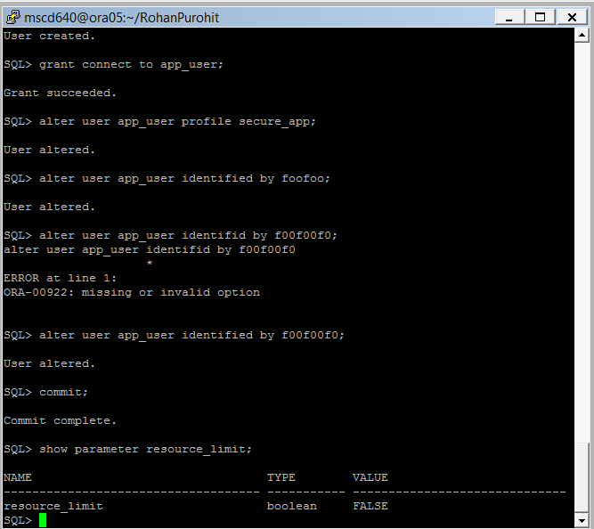
- If it’s not TRUE, then set it:
Ex: SQL> alter system set resource_limit=true scope=both;
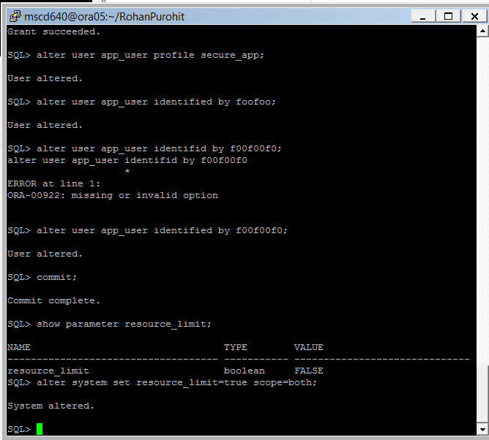
-----------------------------------------------------------------------------------
26. Now create a profile that limits system resource usage.
See pages 146-147 in the book.

Ex: SQL>create profile user_profile_limit
limit
sessions_per_user 20
cpu_per_session 240000
logical_reads_per_session 1000000
connect_time 480
idle_time 2;
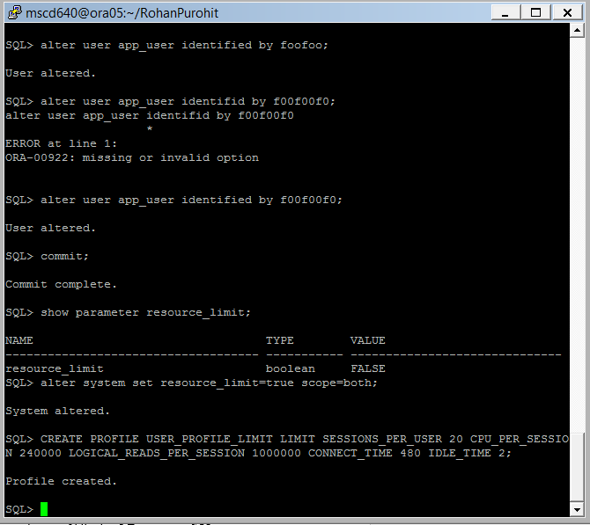
-----------------------------------------------------------------------------------

27. Assign the profile to APP_USER:

- Ex: SQL> alter user app_user profile user_profile_limit;

- Verify:
Ex: SQL> select username, profile from cdb_users where profile like 'USER%';
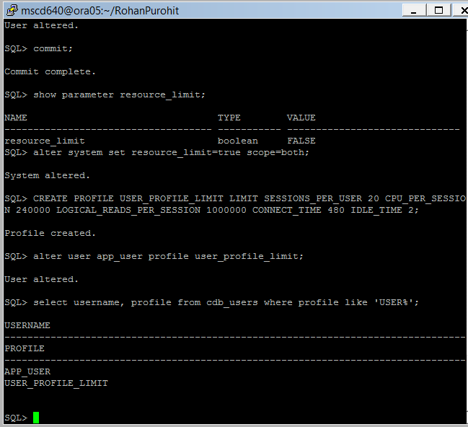
-----------------------------------------------------------------------------------
28. From within your SQLPlus session, connect as APP_USER to your pluggable database:

Replace the xx in the example with your assigned instance number.
- Ex: SQL> conn app_user/ f00f00f0@msc640xpdbxx

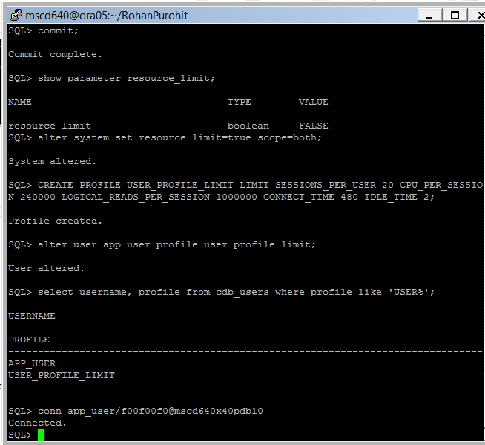
- Don’t type anything in for a few (4) minutes. What happens after a few minutes of idle time? Try to run a SQL statement:

Ex: SQL> select * from user_users;
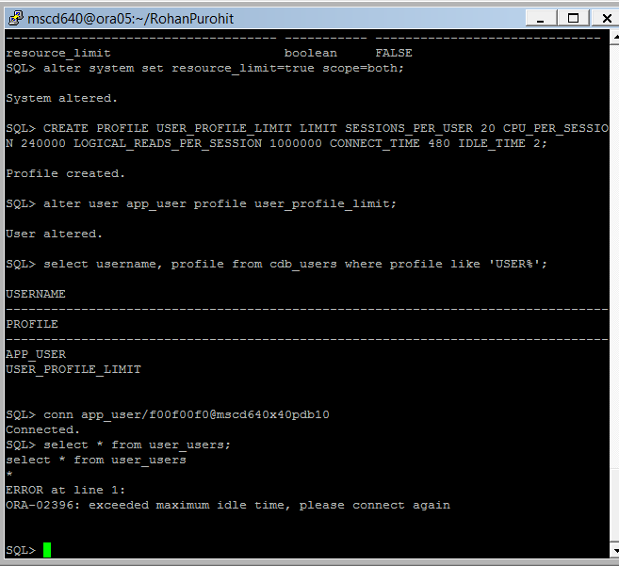
- What happens and why? I exceeded maximum idle time

- Exit SQL
-----------------------------------------------------------------------------------
29. Connect to you PDB as your admin user, and modify the USER_PROFILE_LIMIT profile:

- Replace the xx in the example admin username/password and xpdb number with your assigned instance.
Ex: [mscd640@ora05 ~]$ sqlplus adminxx/adminxx@msc640xpdbxx

- Modify the profile.
Ex: SQL> alter profile user_profile_limit limit idle_time 10;
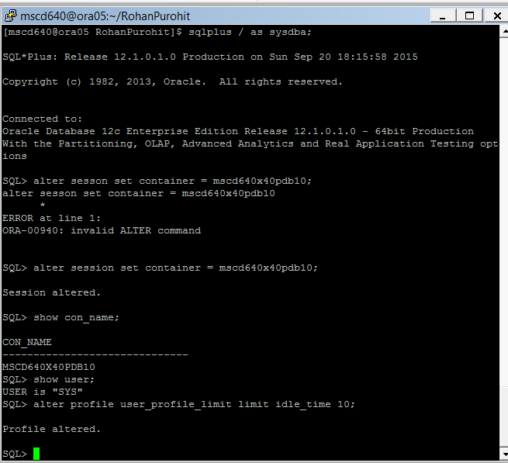
-----------------------------------------------------------------------------------
30. From within your current SQL session, connect as APP_USER and attempt to create a table:

- Replace the xx in the example with your assigned instance number.
Ex: SQL> conn app_user/f00f00f0@msc640xpdbxx

- Display your user name.
Ex: SQL> show user;

- Attempt to create a new table.
Ex: SQL> create table emp(emp_id number);
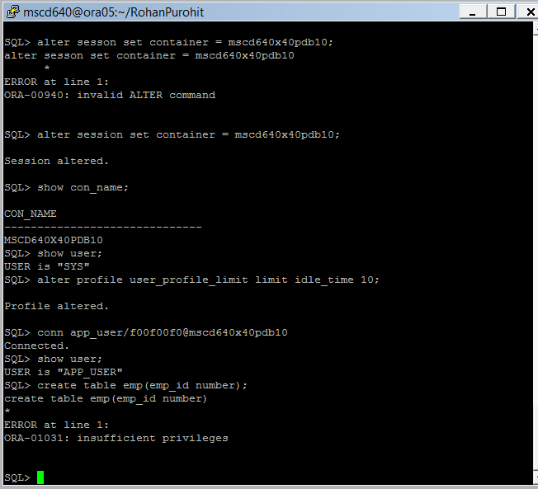
- What happens?
Insufficient privileges.
-----------------------------------------------------------------------------------
31. From within your SQL session reconnect to your ADMIN account and grant some basic privileges to APP_USER:

- Replace the xx in the example admin username/password and PDB name with your assigned instance number.
Ex: SQL> conn adminxx/adminxx@msc640xpdbxx

- Grant privileges to your app user.
Ex: SQL> grant create table to app_user;
SQL> alter user app_user quota unlimited on users;
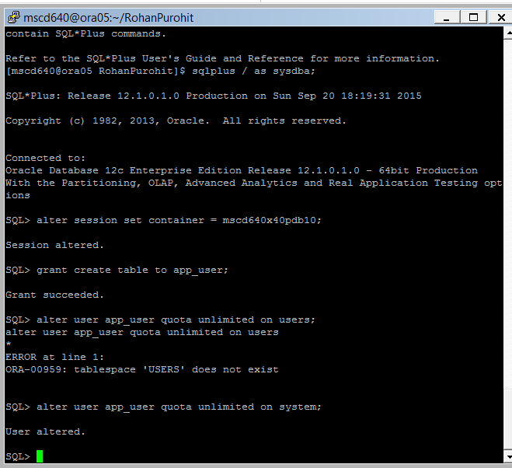
-----------------------------------------------------------------------------------
32. Connect as APP_USER and attempt to create a table:

- From within your current SQL session, connect as APP_USER and attempt to create a table:

Replace the xx in the example with your assigned instance number.
Ex: SQL> conn app_user/f00f00f0@msc640xpdbxx

- Display the current user.
Ex: SQL> show user;

- Now try and create a new table.
Ex: SQL> create table emp(emp_id number);

- Describe your new table:
Ex: SQL> describe emp;

- Add a new row to your table:
Ex: SQL> insert into emp values(1);

- Commit your changes.
Ex: SQL> commit;
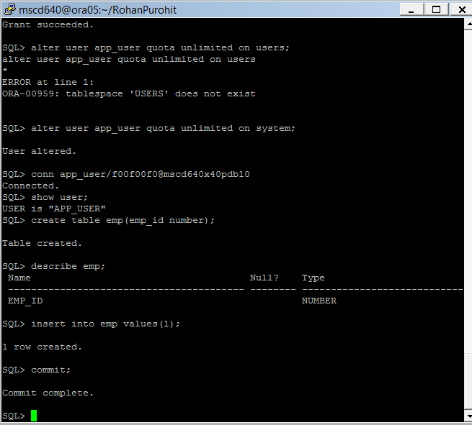
-----------------------------------------------------------------------------------
33. From within your SQL session reconnect to your ADMIN account create another new user named APP_MGMT:

- Replace the xx in the example admin username/password and PDB name with your assigned instance number.
Ex: SQL> conn adminxx/adminxx@msc640xpdbxx

- Create user app_mgmt.
Ex: SQL> create user app_mgmt identified by foo
default tablespace users
temporary tablespace temp;

- Grant connect privilege to app_mgmt user.
Ex: SQL> grant connect to app_mgmt;

- Grant create synonym to app_mgmt.
Ex: SQL> grant create synonym to app_mgmt;

- Grant unlimited resource on users to app_mgmt.
Ex: SQL> alter user app_mgmt quota unlimited on users;
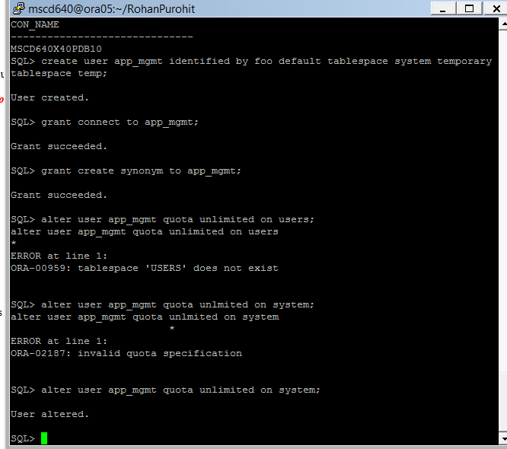
-----------------------------------------------------------------------------------
34. From within your SQLPlus session, connect as APP_USER and grant object privileges on the table EMP to APP_MGMT:

Replace the xx in the example PDB name with your assigned instance number.
- Ex: SQL> conn app_user/f00f00f0@msc640xpdbxx

- Grant object privileges to app_mgmt user.
Ex: SQL> grant insert, update, delete, select on emp to app_mgmt;
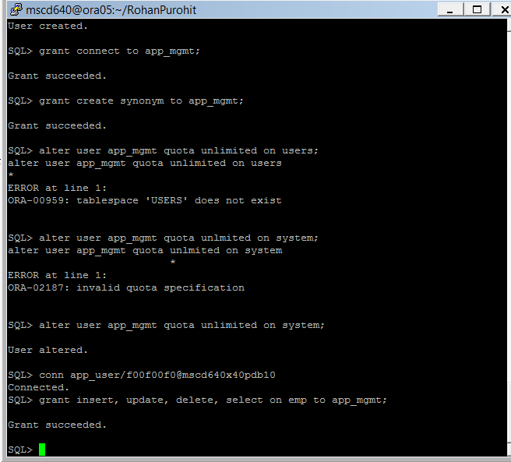
- Why can you grant the object privleges to app_mgmt?
Because we granted permissions to create object privleges in the previous command.
-----------------------------------------------------------------------------------

35. From within your SQLPlus session connect as APP_MGMT and see if you can perform DML operations on the APP_USER.EMP table:

Replace the xx in the example PDB name with your assigned instance number.
- Ex: SQL> conn app_mgmt/foo@msc640xpdbxx

- Insert a new row into the app_user.emp table/
Ex: SQL> insert into app_user.emp values(2);

- Save your changes.
Ex: SQL> commit;

- Display all the records in app_user.emp table.
Ex: SQL> select * from app_user.emp;
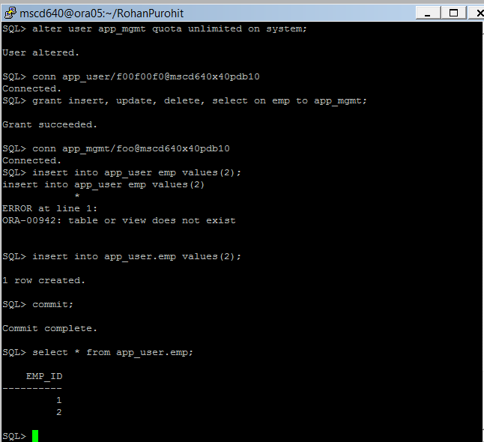
- Why do you have to place the schema name (of app_user) before the table name?
Because the table has to be recognized by its parent tablespace schema. The table is a child of the schema.
-----------------------------------------------------------------------------------
36. As APP_MGMT, create a synonym:

- Try selecting all from the emp table without prefixing the tablename with the owner name.
Ex: SQL> select * from emp;
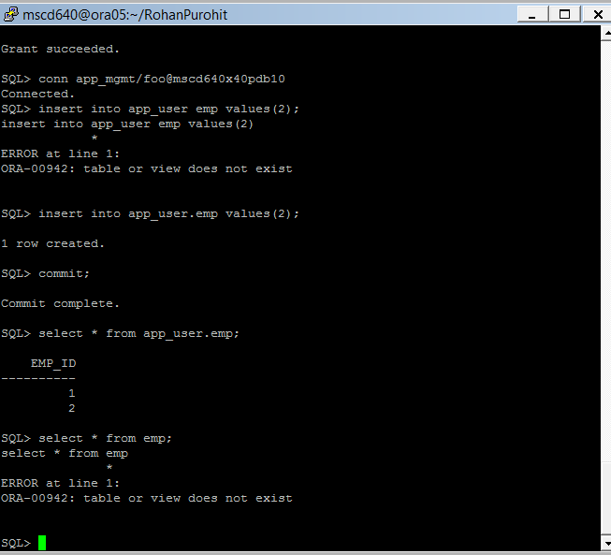
- What happens and why?
Table doesn’t exist because it doesn’t belong to a particular schema.
- Create a synonym that will let you access the table.
Ex: SQL> create synonym emp for app_user.emp;

- Now try to display the records from app_user.emp table without the owner name.
Ex: SQL> select * from emp;
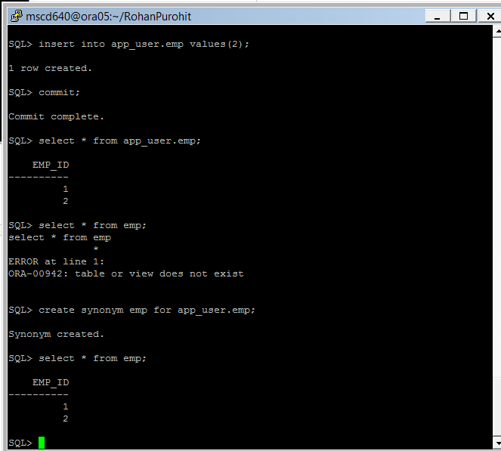
- Why don’t you have to place the schema name in front of the table name anymore?
Because the synonym has the same privileges as a schema specification for the emp table.
-----------------------------------------------------------------------------------
37. From your current SQLPlus session, connect to your admin user account and create a new role:

- Replace the xx in the example admin username/password and PDB name with your assigned instance number.
Ex: SQL> conn adminxx/adminxx@msc640xpdbxx

- Create a new role called app_read.
Ex: SQL> create role app_read;

- Now grant select on table app_user.emp to the role app_read.
Ex: SQL> grant select on app_user.emp to app_read;

- Now create a new user.
Ex: SQL> create user app_select identified by foo
default tablespace users
temporary tablespace temp;

- Grant connect privileges to your new user.
Ex: SQL> grant connect to app_select;

- Grant the new app_read role to your new user.
Ex: SQL> grant app_read to app_select;
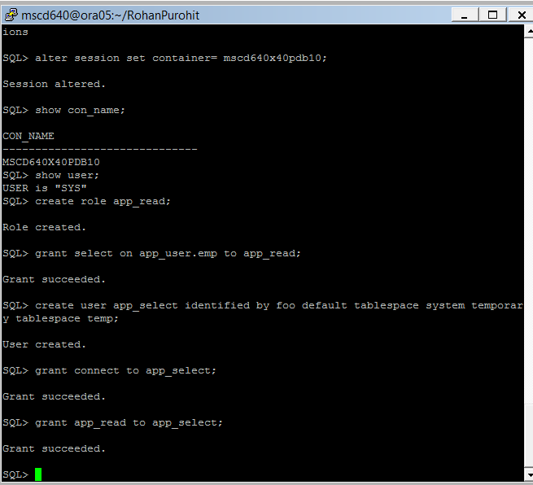
-----------------------------------------------------------------------------------

38. From your current session, connect as app_select and see if it has access to the underlying table:

Replace the xx in the example PDB name with your assigned instance number.
- Ex: SQL> conn app_select/foo@msc640xpdbxx

- Display all the records in the app_user.emp table.
Ex: SQL> select * from app_user.emp;
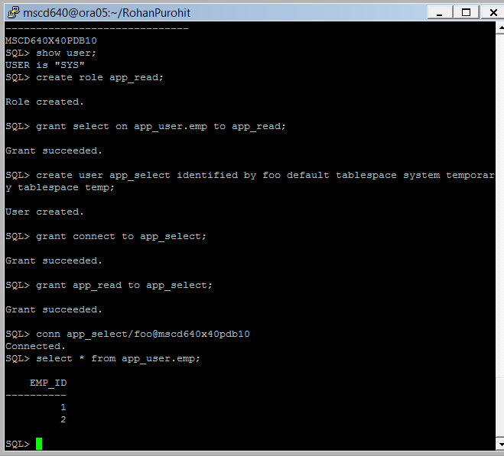
-----------------------------------------------------------------------------------

-----------------------------------------------------------------------------------
Lab 2, Part 2: Tables and Constraints
Read Chapter 7 in the book.
-----------------------------------------------------------------------------------
39. From your current session, connect to your admin user account in your PDB in order to create another new user and grant appropriate privileges.

- Replace the xx in the example admin username/password and PDB name with your assigned instance number.
Ex: SQL> conn adminxx/adminxx@msc640xpdbxx

- Create a new user named inv_user.
Ex: SQL> create user inv_user identified by foo
default tablespace users
temporary tablespace temp;

- Grant connect to your new user.
Ex: SQL> grant create session to inv_user;

- Grant create table privilege to your new user.
Ex: SQL> grant create table to inv_user;

- Grant unlimited quota on the default user tablespace users.
Ex: SQL> alter user inv_user quota unlimited on users;
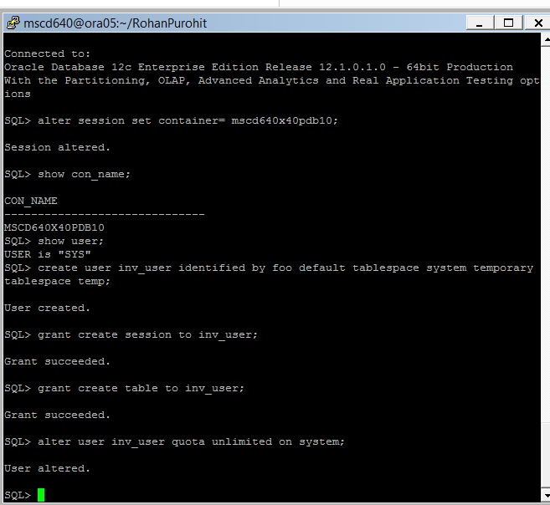
-----------------------------------------------------------------------------------

40. Connect as INV_USER and create a heap-organized table that contains number, varchar, date, and timestamp type columns.
See page 160-163 in the book.

Replace the xx in the example PDB name with your assigned instance number.
- Ex: SQL> conn inv_user/foo@msc640xpdbxx

- Create table d_sources.
Ex: SQL> create table d_sources(
d_source_id number not null,
source_type varchar2(32),
create_dtt date default sysdate not null,
update_dtt timestamp(5)
);
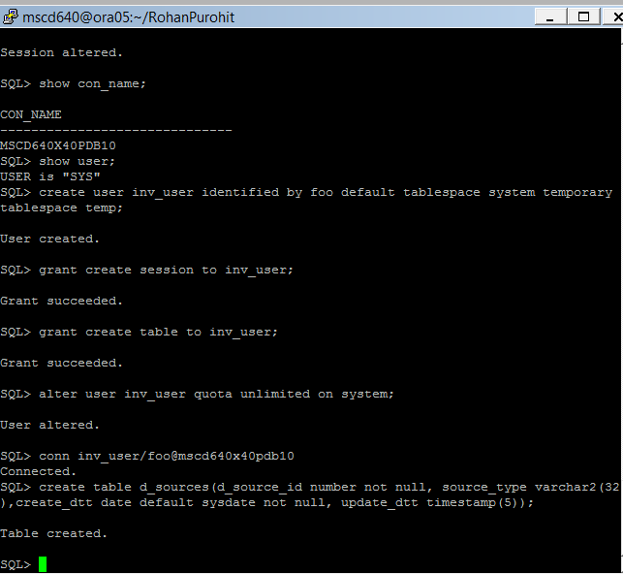
-----------------------------------------------------------------------------------
41. Run the following query to determine if table d_sources contain any segments and extents.

- Ex: SQL> select count(*) from user_segments where segment_name = 'D_SOURCES';
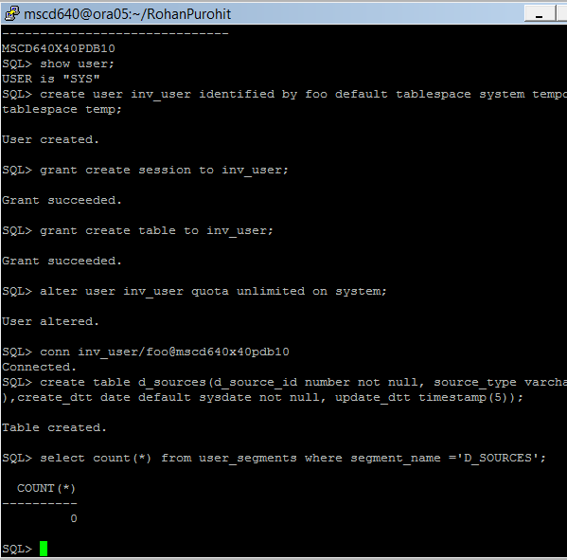
- Why or why not are any segments and extents found in table d_sources?

The table has no segments. Because the tablespace datafile has empty extents, it doesn’t have any entries or any rows so segments and extents on disk haven’t been written to.
42. Insert a row into the D_SOURCES table. Verify that the data dictionary now contains information regarding segments and extents for the table.
See pages 167-168 in the book.

- Ex: SQL> insert into d_sources (d_source_id, source_type) values(1, 'HQ');

- Display the number of user_segments now found in table D_SOURCES.
Ex: SQL> select count(*) from user_segments where segment_name = 'D_SOURCES';

- Display all the records contained in table D_SORUCES.
Ex: SQL>select * from d_sources;

- Display the number of user_extents found in table D_SOURCES.
Ex: SQL>

- Commit your updates.
Ex: SQL> commit;
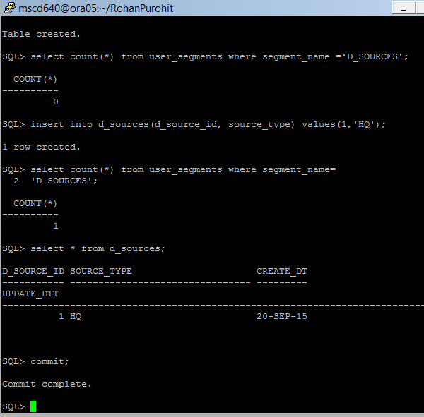
- Define Oracle’s deferred segment creation feature.
Deferred segment creation allows tables and indexes to be created without physical segments which can be a double-edged sword as it allows objects to be created even if there is no space available for those objects in the specified tablespace. Just like the user who has no quota on the desired tablespace a false sense of security can result when the database reports 'Table created' or 'Index created'. The data dictionary contains the object information so a query of DBA_TABLES, DBA_INDEXES or any of the %TAB% and %IND% tables and views will return the expected information. Querying DBA_SEGMENTS, however, may fail to return data since an object may not have any segments associated with it:
----------------------------------------------------------------------------------------------------------------------

43. As INV_USER, create two tables that are related by a foreign key constraint.
See pages 161-162 in the book.

- Create table operating_systems.
Ex: SQL> create table operating_systems(
operating_system_id number(19, 0) not null,
version varchar2(50),
os_name varchar2(256),
release varchar2(50),
vendor varchar2(50),
create_dtt date default sysdate not null,
update_dtt date,
constraint operating_systems_pk primary key (operating_system_id)
using index tablespace users
)
tablespace users
;
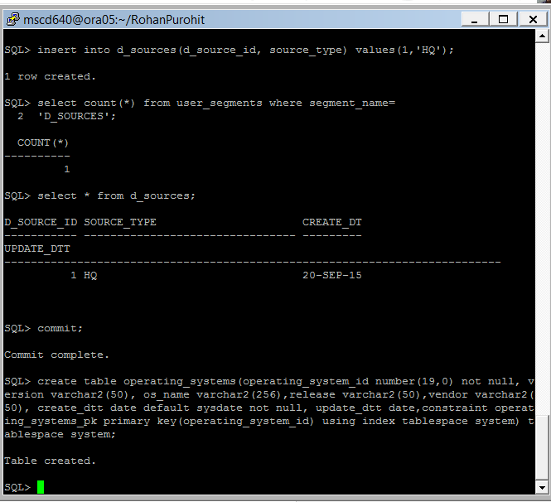
- Create a unique index on table operating_systemss
Ex: SQL> create unique index operating_system_uk1 on operating_systems
(os_name, version, release, vendor)
tablespace users
;
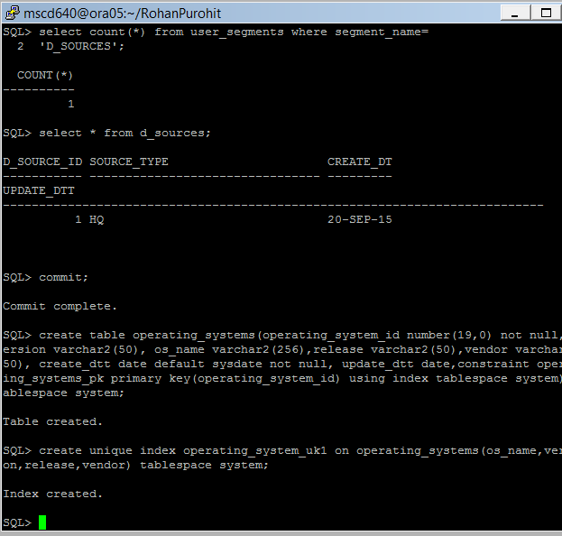

- Create table computer_systems
Ex: SQL> create table computer_systems(
computer_system_id number(38, 0) not null,
agent_uuid varchar2(256),
operating_system_id number(19, 0) not null,
hardware_model varchar2(50),
create_dtt date default sysdate not null,
update_dtt date,
constraint computer_systems_pk primary key (computer_system_id)
using index tablespace users
) tablespace users;
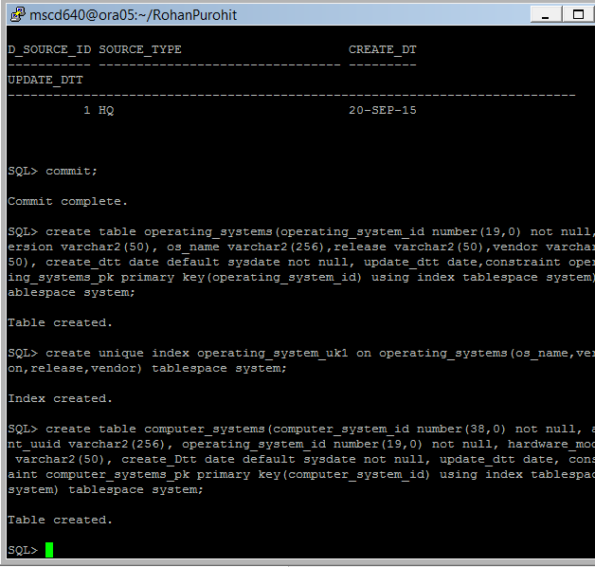
- Add a common to table computer system column computer_system_id.
Ex: SQL> comment on column computer_systems.computer_system_id is
'Surrogate key generated via an Oracle sequence.';
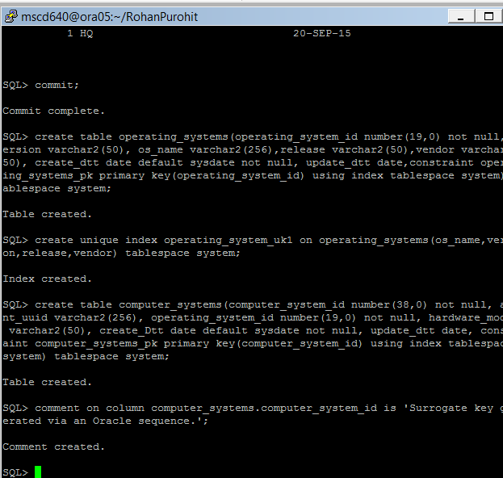

- Create a unique index on table computer_systems
Ex: SQL> create unique index computer_system_uk1 on computer_systems(agent_uuid)
tablespace users;
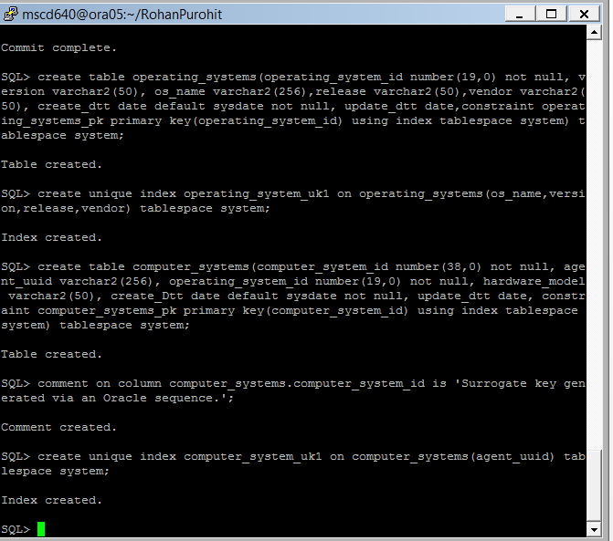
- Add a foreign key constraint on table computer_systems referencing table operating_systems.
Ex: SQL> alter table computer_systems add constraint computer_systems_fk1
foreign key (operating_system_id)
references operating_systems(operating_system_id);
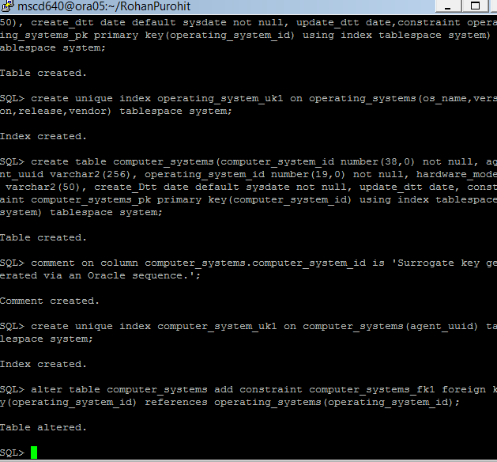
---------------------------------------------------------------------------------------------------------------------------------

44. As INV_USER, verify the new tables, indexes, constraints, and comments created in exercise 43:

- Display all tables owned by INV_USER.
Ex: SQL> select table_name, status from user_tables;
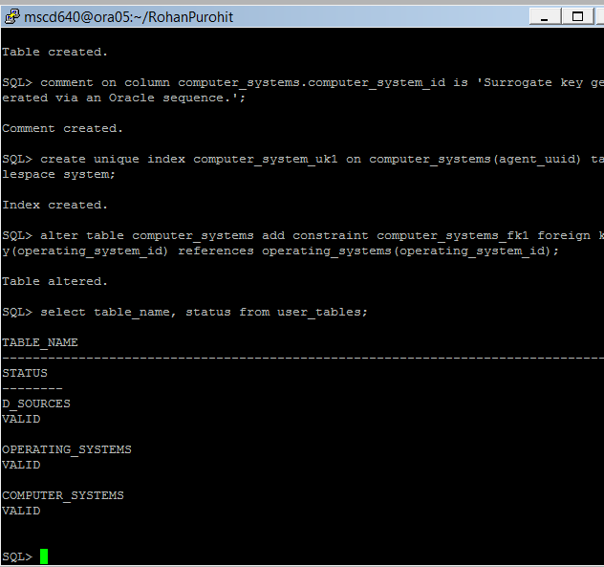
- Display all Indexes owned by user INV_USER.
Ex: SQL> select table_name, index_name, status, index_type from user_indexes;
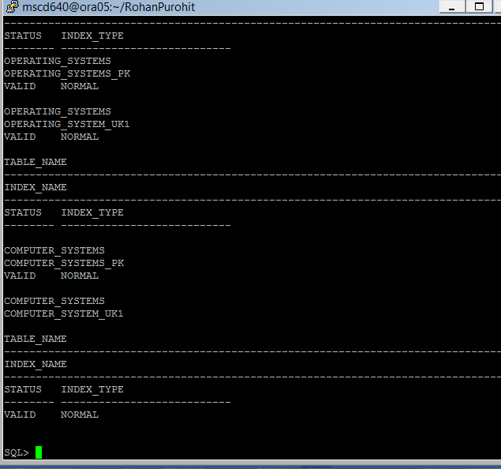
- Display all constraints owned by user INV_USER.
Ex: SQL> select table_name, constraint_name, constraint_type from user_constraints;
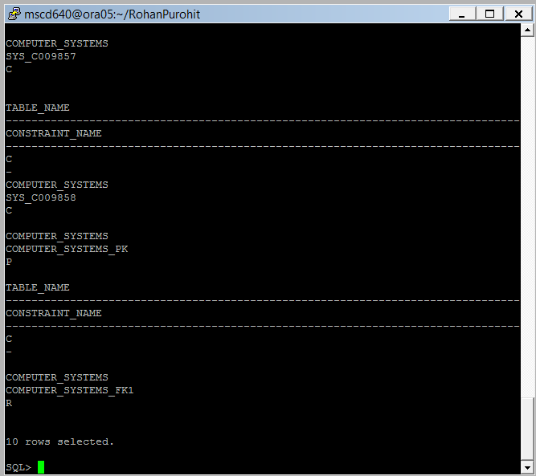
- Display all user column comments created by INV_USER.
Ex: SQL> select table_name, column_name, comments from user_col_comments where comments is not null;
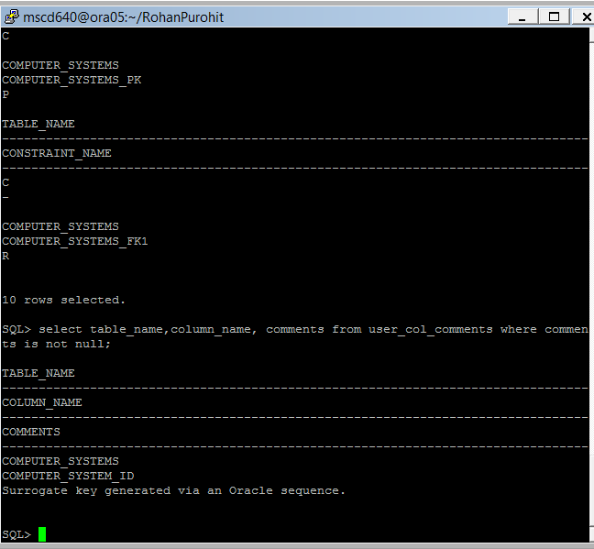
-----------------------------------------------------------------------------------
45. As INV_USER, create a table with a virtual column.
See pages 164-166 in the book.

- Create table INV with a virtual column.
Ex: SQL> create table inv(
inv_id number
,inv_count number
,inv_status generated always as (
case when inv_count <= 100 then 'GETTING LOW'
when inv_count > 100 then 'OKAY'
end)) tablespace users ;

- Verify the table creation by the stored table create ddl:
EX: SQL> set long 10000;
SQL> select dbms_metadata.get_ddl('TABLE','INV') from dual;
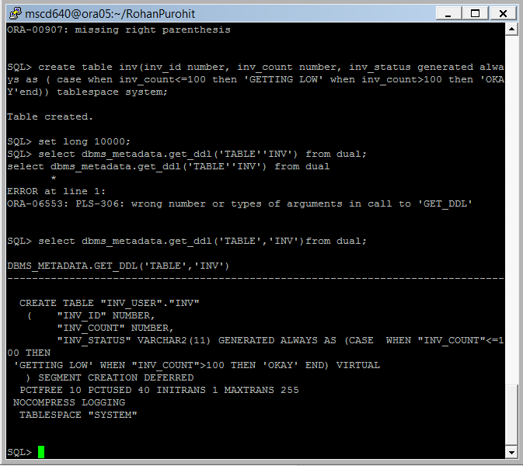
-----------------------------------------------------------------------------------

46. Insert data into INV, and verify that the virtual column works as expected:

- Insert a row into INV.
Ex: SQL> insert into inv (inv_id, inv_count) values (1,100);

- Commit your updates.
Ex: SQL> commit;

- Select all rows from table INV. Verify the INV_STATUS.
Ex: SQL> select * from inv;
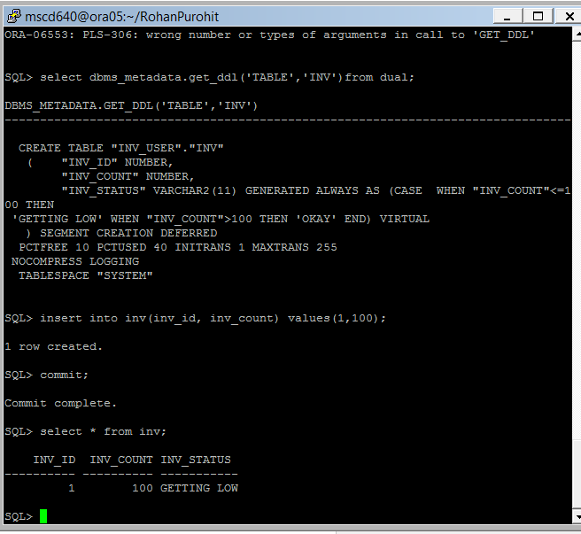
- What are the main advantages to using virtual columns?
A virtual virtual column is a column whose value is computed as a reaction for a defined operation. This means that they are computed “on the fly” – only when needed. It's accessible like any other column except that there is no physical space associated with it. If a SQL query doesn't reference a virtual column, the value is not calculated. A virtual column in a table provides benefits in disk space utilization. It only stores metadata. It doesn't consume physical space (only the small amount of metadata in the data dictionary), but it can be indexed (any indexes created on virtual columns will require storage space). It can also contain optimizer statistics and histograms. Using virtual columns in tables also eliminates the need to use views to display derived column values.
-----------------------------------------------------------------------------------
47. Make the INV table read only.
See pages 167 in the book.

- Ex: SQL> alter table inv read only;

- Verify your table status.
Ex: SQL> select table_name, read_only from user_tables where read_only='YES';
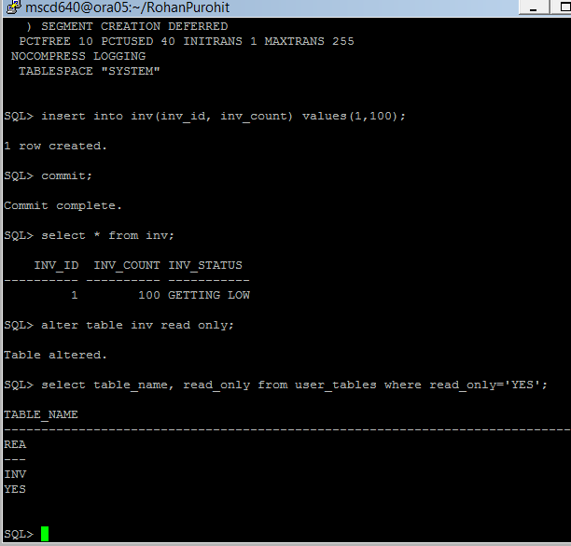
- Try to insert some data to table INV.
Ex: SQL> insert into inv (inv_id, inv_count) values (2,200);

- What error is returned? Why?
Yes because the columns are read only.
-----------------------------------------------------------------------------------

48. Drop and re-create table INV. Use the compression feature.
See pages 172-173 in the book.

- Drop table INV with the purge option.
Ex: SQL> drop table inv purge;

- Recreate table inv with compression option.
Ex: SQL> create table inv(
inv_id number
,inv_name varchar2(64)
) compress for oltp
tablespace users;

- Verify the table compression option.
Ex: SQL> select
table_name
,compression
,compress_for
from user_tables where table_name='INV';
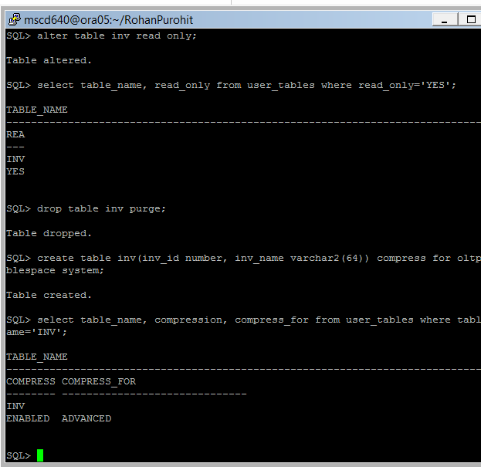
----------------------------------------------------------------------------------------------------------------------------
49. Drop and re-create table INV with NOLOGGING enabled.
See pages 174-176 in the book.

- Drop table INV with the purge option.
Ex: SQL> drop table inv purge;

- Create table INV with nologging option.
Ex: SQL> create table inv(inv_id number)
tablespace users
nologging;

- Insert some data to table INV using a direct path feature (such as an append hint):
Ex: SQL> insert /*+ append_values */ into inv values(1);

- Select all the rows from table inv.
Ex: SQL> select * from inv;
- 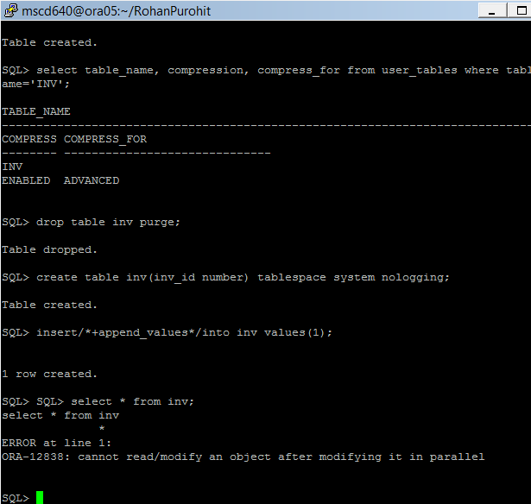 What happened, what ORA error is returned and why?
We cannot read/modify an object after modifying it in parallel.
- Commit your work.
Ex: SQL> commit;

- Now select all records from table INV.
Ex: SQL> select * from inv;
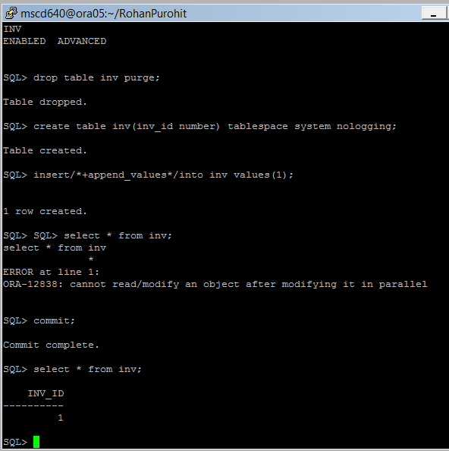
- What are the advantages to using nologging combined with a direct path loading operation?
It allows for faster writes to the disk. The benefits of the NOLOGGING option are:
- Will save disk space when the archive option is enabled.
- Will largely reduce I/O on the redologs.
- Will reduce the time it takes to complete the operation.

-----------------------------------------------------------------------------------
50. Still using your INV user, create a table using the CTAS approach.
See page 176 in the book.

- Create a new table in your schema which duplicates the table all_users.
Ex: SQL> create table test_users tablespace users as select * from all_users;

- Describe your new table.
Ex: SQL> desc test_users

- Select a count from your new table.
Ex: SQL> select count(*) from test_users;

- Select a count from the copied table.
Ex: SQL> select count(*) from all_users;
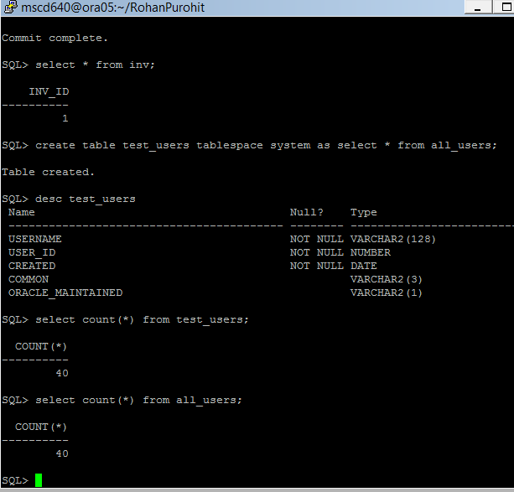
-----------------------------------------------------------------------------------

51. Explain under what circumstances a DBA would use DDL_LOCK_TIMEOUT?
See page 178 in the book.

-----------------------------------------------------------------------------------
52. Rename the INV table to INV_OLD.
See page 179 in the book.

- Ex: SQL> rename inv to inv_old;

- Why would you want to rename a table?
We would like to rename tables if new tables need to follow a new naming scheme. There are changes in table names for a organization.
- Rename INV_OLD back to INV.
Ex: SQL> Rename INV_OLD to INV;
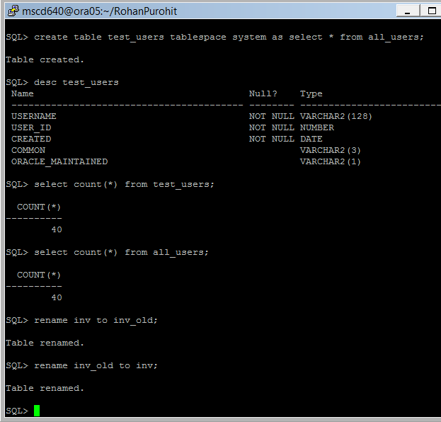
-----------------------------------------------------------------------------------

53. Add two columns to table INV.
See page 179-181 in the book.

- Add column inv_count to table INV.
Ex: SQL> alter table inv add(inv_count number);

- Add a new description column to table INV.
Ex: SQL> alter table inv add(inv_desc varchar2(10));

- Verify the new table structure:

SQL> desc inv;
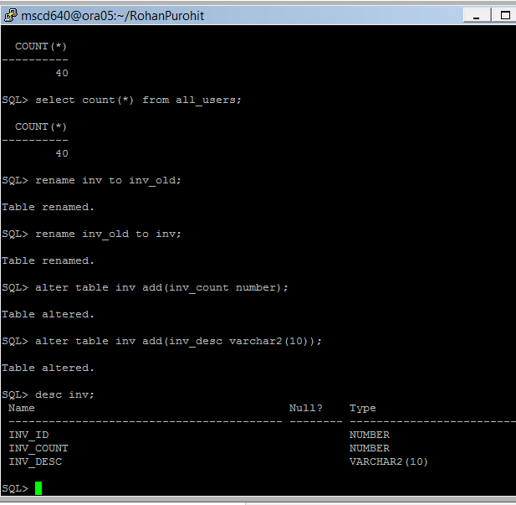
-----------------------------------------------------------------------------------

54. Alter a column in the INV table.
See pages 179-180 in the book.

- Change the size of column inv_desc.
Ex: SQL> alter table inv modify inv_desc varchar2(256);

- Verify your changes.
Ex: SQL> desc inv;
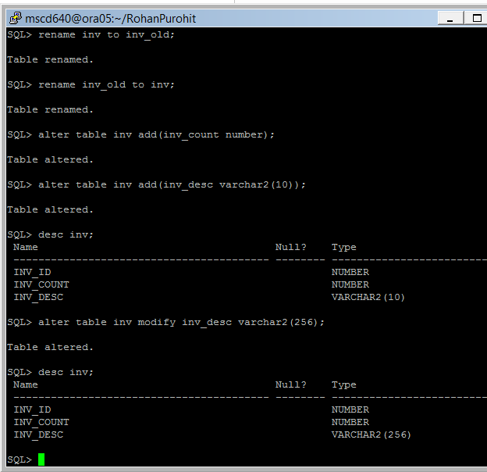
-----------------------------------------------------------------------------------

55. Rename a column in the INV table.
See page 181 in the book.

- Give column inv_count an new name.
Ex: SQL> alter table inv rename column inv_count to inv_amt;

- Verify your changes.
Ex: SQL> desc inv;

- Save your changes.
Ex: SQL> commit;
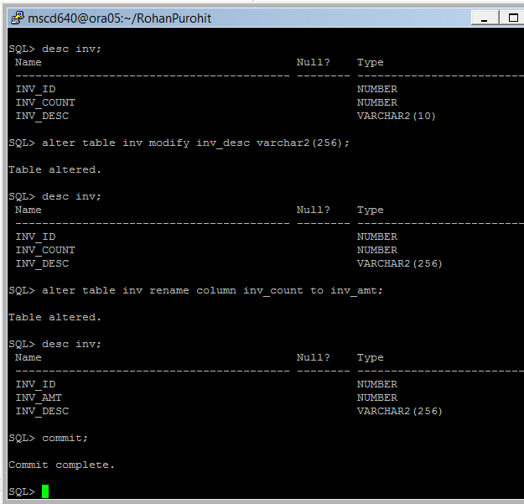
-----------------------------------------------------------------------------------

-----------------------------------------------------------------------------------
Lab 2, Part 3: Indexes
Read Chapter 8 in the book.
-----------------------------------------------------------------------------------
56. From your current SQL session connect as your INV_USER account (if not already connected).
Replace the xx in the example PDB name with your assigned instance number.
- Ex: SQL> conn inv_user/foo@msc640xpdbxx

-----------------------------------------------------------------------------------
56. Verify that the d_sources table is still valid:

- Ex: SQL> desc d_sources;
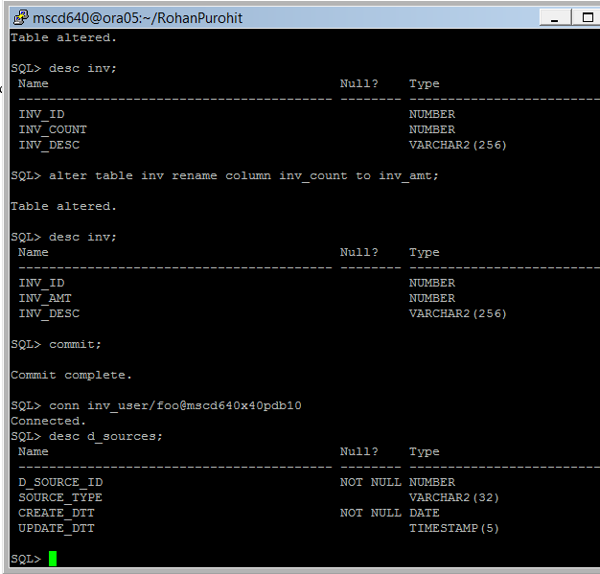
-----------------------------------------------------------------------------------
57. Create a new index on table d_sources.
See pages 214-216 in the book.

- Create an index on column d_sources.d_source_id.
Ex: SQL> create index d_sources_idx1 on d_sources(d_source_id);

- Verify your changes.
Ex: SQL> select index_name, index_type, table_name, tablespace_name
from user_indexes
where table_name = 'D_SOURCES';
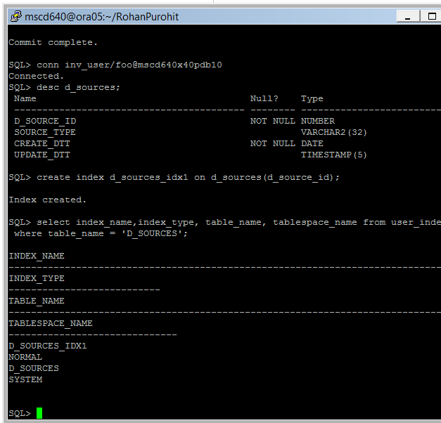
---------------------------------------------------------------------------------------

58. Drop the newly created index.
Ex: SQL> drop index d_sources_idx1;
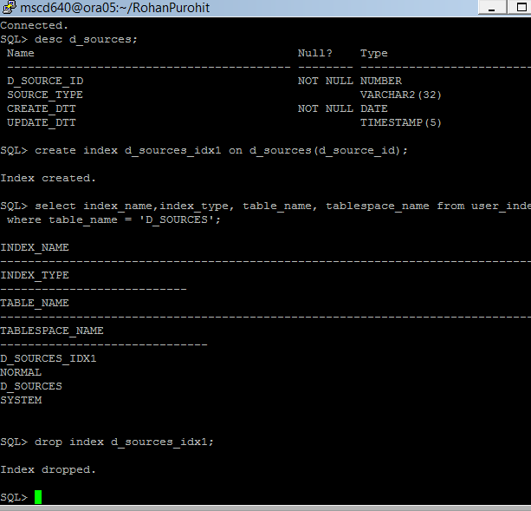
-----------------------------------------------------------------------------------

59. Drop the previously created INV table and re-create it.
See page 183 in the book.

- Drop table INV.
Ex: SQL> drop table inv purge;

- Recreate table INV.
Ex: SQL> create table inv(
inv_name varchar2(30)
,cust_name varchar2(30))
tablespace users;

- Verify the table build.
Ex: SQL> desc inv;
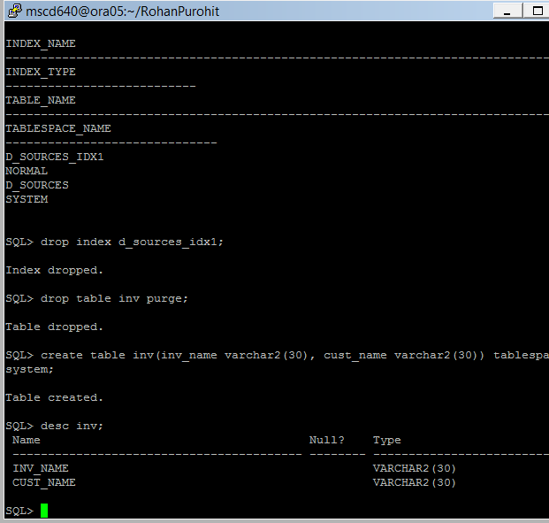
-----------------------------------------------------------------------------------
60. Create a concatenated index on table inv.
See pages 217-218 in the book.

- Create a concatenated index using columns inv_name and cust_name.
Ex: SQL> create index inv_idx3 on inv(inv_name, cust_name);

- Verify the index creation.
Ex: SQL> select index_name, column_name, column_position
from user_ind_columns
where index_name = 'INV_IDX3';

- Save your changes.
Ex: SQL> commit;
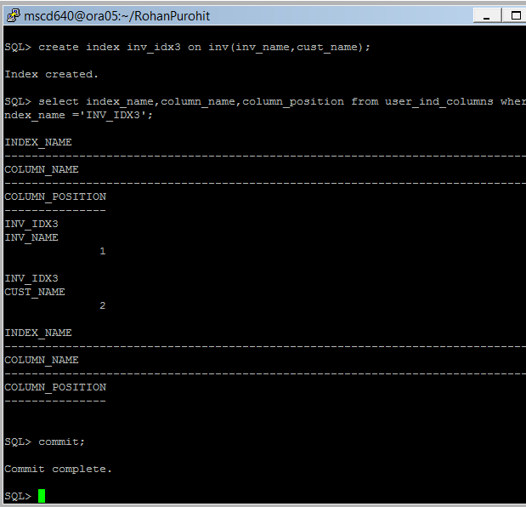

- What is the advantage of creating a concatenated index?
When a single index has multiple columns that are indexed, it is called a concatenated or composite index. The advantage of using a composite index is that you have faster access to multiple columns. While Oracle 9i’s introduction of skip-scan index access has increased the optimizer’s options when using concatenated indexes, you should be careful when selecting the order of the columns in the index. In general, the leading column of the index should be the one most likely to be used in WHERE clauses and also the most selective column of the set.
-----------------------------------------------------------------------------------
61. Create a table named emp:
SQL> create table emp(emp_id number, emp_name varchar2(30)) tablespace users;
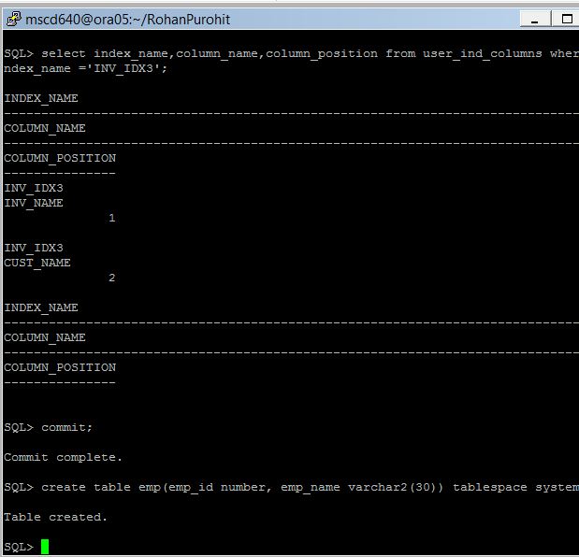
-----------------------------------------------------------------------------------
62. Create a function based index.
See page 218 in the book.

- Create a function to uppercase values inserted into column emp.emp_name.
Ex: SQL> create index user_upper_idx on emp(upper(emp_name)) tablespace users;

- Verify the index creation.
Ex: SQL> SET LONG 500
SQL> select index_name, column_expression from user_ind_expressions;
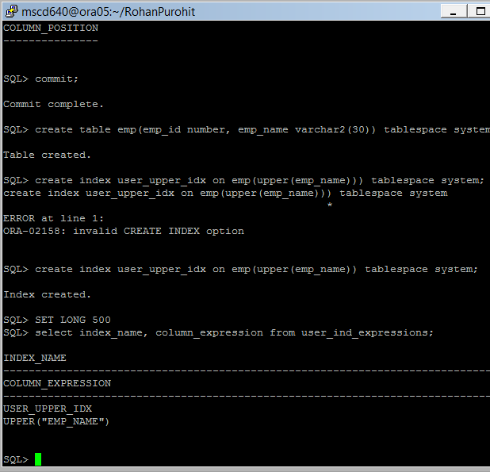
-------------------------------------------------------------------------------
63. Add a column to the INV table:

- Ex: SQL> alter table inv add(sku_id number);

- Verify your column addition.
Ex: SQL> desc inv;
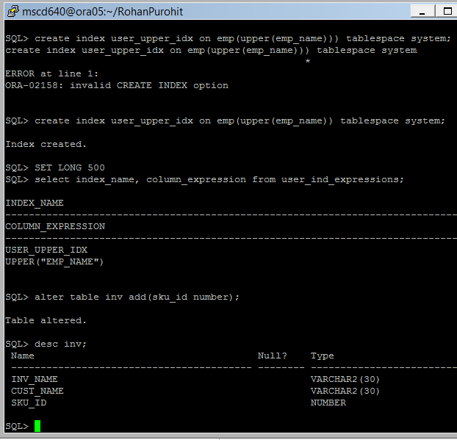
--------------------------------------------------------------------------------------------------------------------------------
64. Create a unique index on INV.SKU_ID.
See pages 219-220 in the book.

- Ex: SQL> create unique index inv_uidx1 on inv(sku_id) tablespace users;

- Verify the unique index creation.
Ex: SQL> insert into inv(sku_id) values (1);

- Try to insert a duplicate value into INV.sku_id column.
Ex: SQL> insert into inv(sku_id) values (1);

- What error is returned and why? Unique constraint is violated as duplicate values are not permitted.
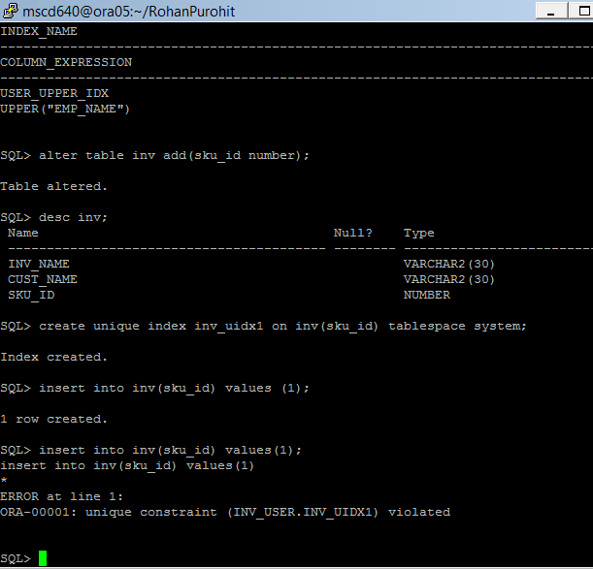
----------------------------------------------------------------------------------------
65. Verify your created unique index via the data dictionary:

- Ex: SQL> select index_name, uniqueness from user_indexes;
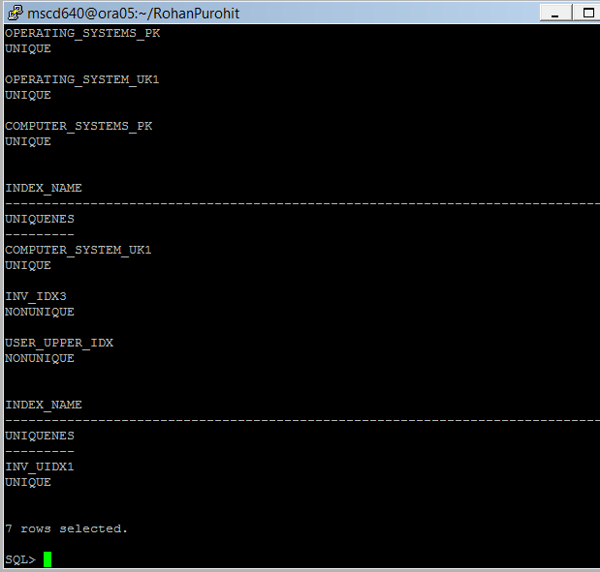
-----------------------------------------------------------------------------------
66. Create a reverse-key index.
See pages 222 in the book.

- Add a new column to the INV table.
Ex: SQL> alter table inv add(inv_id number);

- Verify the new column addition in the INV table.
Ex: SQL> desc inv;

- Create the reverse key index on the new column inv_id.
Ex: SQL> create index inv_idx1 on inv(inv_id) reverse;

- Verify the reverse index in the user_indexes view.
Ex: SQL> select index_name, index_type from user_indexes;

- What is the main advantage of a reverse-key index?
A reverse-key index is B*Tree index where the bytes of each indexed column
stored in a reverse order. They are very useful for Oracle Parallel Server
where contention for the same leaf blocks during data inserts can cause
inter-instance "pinging", excessive I/O and performance degradation.
Reversing index keys allows insertions to be distributed evenly across
all the leaf keys in the index.
But reverse-key indexes do not allow index range scan since lexically
adjacent keys are not stored next to each other, so you probably should not
use reverse-key indexes unless you are in OPS environment.
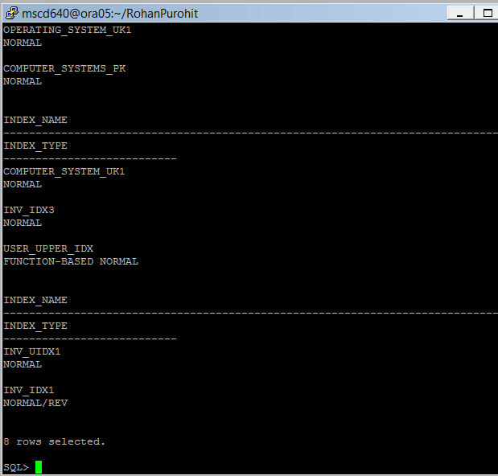
-----------------------------------------------------------------------------------

67. Create a table and a key compressed index.
See page 223 in the book.

- Create table users.
Ex: SQL> create table users(
last_name varchar2(30)
,first_name varchar2(30)
,address_id number)
tablespace users;

- Create a key compressed index.
Ex: SQL> create index users_idx1 on users(last_name, first_name) compress 2 tablespace users;
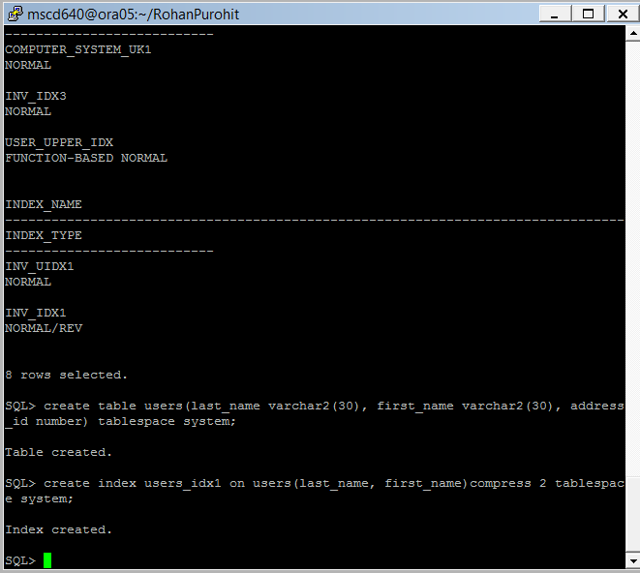
- Verify the index creation from the user_indexes view.
Ex: SQL> select
index_name
,compression
from
user_indexes
where index_name like 'USERS%';
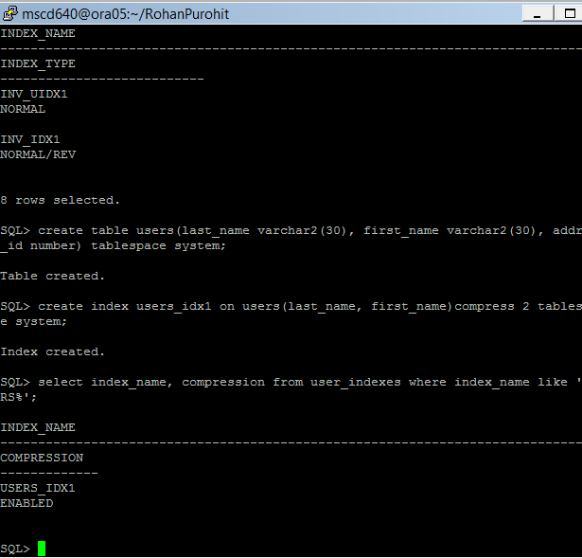
- What is the advantage of compression?
The benefits of compression come from the fact that a properly compressed index uses a smaller number of leaf blocks – which tends to mean that less I/O is involved when the index is used, there is a reduced amount of buffer cache flushing, and the optimizer is likely to calculate a lower cost for using that index for range scans. But the number of branch blocks, and the index height may not be reduced.Although key compression reduces the storage requirements of an index, it can increase the CPU time required to reconstruct the key column values during an index scan. It also incurs some additional storage overhead, because every prefix entry has an overhead of 4 bytes associated with it.

-----------------------------------------------------------------------------------
68. Make an existing index an invisible index.
See pages 225 in the book.

- Review your currently created index visibility status.
Ex: SQL> select index_name, status, visibility from user_indexes;
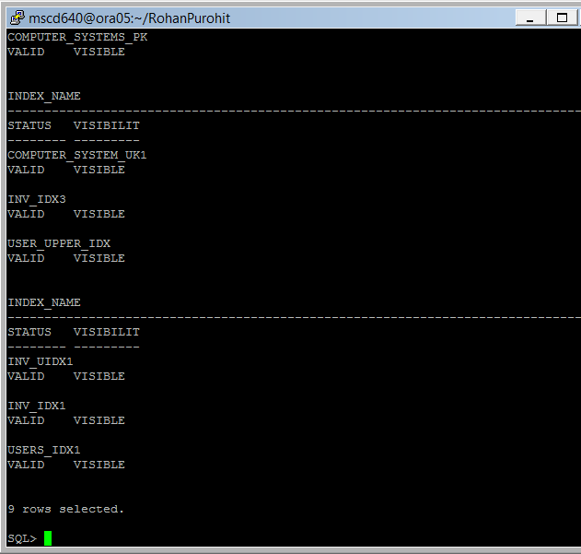
- Change index inv_idx1 from visible to invisible.
Ex: SQL> alter index inv_idx1 invisible;

- Verify your change.
Ex: SQL> select index_name, status, visibility from user_indexes;
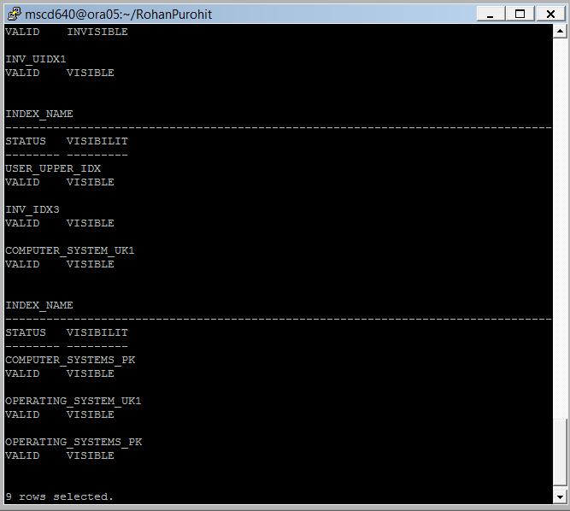
- Why would you want to use an invisible index?
Oracle 11g introduces a new feature for indexes, invisible indexes, that is useful in several different situations. An invisible index is an index that is maintained by the database but ignored by the optimizer unless explicitly specified. The invisible index is an alternative to dropping or making an index unusable.
-----------------------------------------------------------------------------------
69. Display the code to recreate an index.
See page 227 in the book.

SQL> set long 10000
SQL> select dbms_metadata.get_ddl('INDEX','INV_IDX1') from dual;
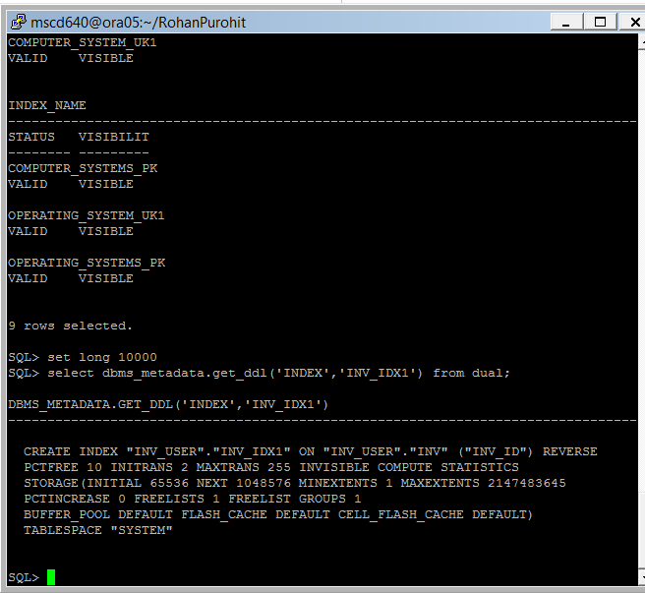
------------------------------------------------------------------------------------------

70. Rebuild an index using parallel and nologging.
See pages 227-228 in the book.

- Ex: SQL> alter index inv_idx1 rebuild parallel nologging;
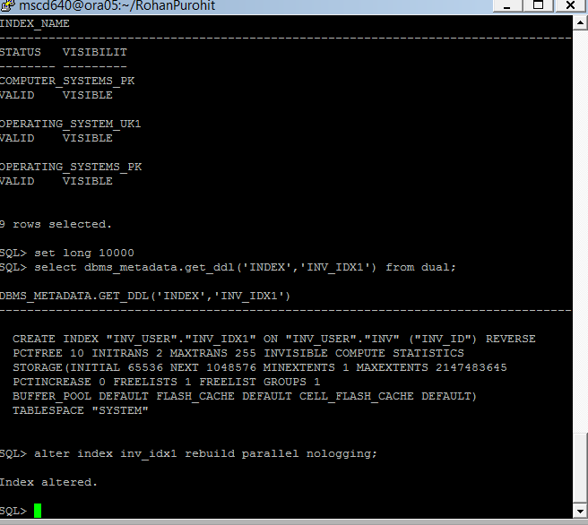
- DBAs often debate the merits of rebuilding an index. What are some valid reasons for rebuilding an index?
- Index fast full scans may run faster after index reorganization whenever the “density” of the index entries becomes greater. In other words, it takes less time to read 100,000 entries from a 100 block index than reading the entries from a 500 block index.
- Multi-block Index range scans will run faster when the data blocks are arranged in index-key order and when the data blocks have a high number of row entries (as evidenced by clustering_factor in dba_indexes).
- Large-table full-table scans will run faster after reorganization when the table has excessive chained or relocated rows, or low block density after massive DML (updates and deletes).
- Table updates will run faster after reorganizations when the table has unbalanced freelists (with multi-freelist, freelist groups table in the obsolete dictionary-managed tablespaces only).
In an OracleWorld 2003 presentation titled “Oracle Database 10g: The Self-Managing Database” by Sushil Kumar of Oracle Corporation, Kumar states that the new Automatic Maintenance Tasks (AMT) Oracle10g feature will "automatically detect and re-build sub-optimal indexes.“
In a paper titled “Metric Baselines: detecting and explaining performance events in em 10gr2” (Presented at the RMOUG 2005 Training Days), John Beresniewicz of Oracle Corporation notes that the use of "baselines to capture and adapt thresholds to expected time-dependent workload variations" is a core feature of the next release of Oracle
-----------------------------------------------------------------------------------
Lab 2, Part 4: Views, Synonyms, and Sequences
Read Chapter 9 in the book.
-----------------------------------------------------------------------------------
71. Ensure that the CREATE VIEW system privilege, CREATE SYNONYM, and CREATE SEQUENCE system privilege has been granted to INV_USER.

- From your current session, connect to your admin account for your PDB.
Replace the xx in the example admin username/password and PDB name with your assigned instance number
Ex: SQL> conn adminxx/adminxx@msc640xpdbxx

- Grant the create view privilege to the INV_USER.
Ex: SQL> grant create view to inv_user;

- Grant the create synonym privilege to the INV_USER.
Ex: SQL> grant create synonym to inv_user;

- Grant create sequence privilege to the INV_USER.
Ex: SQL> grant create sequence to inv_user;
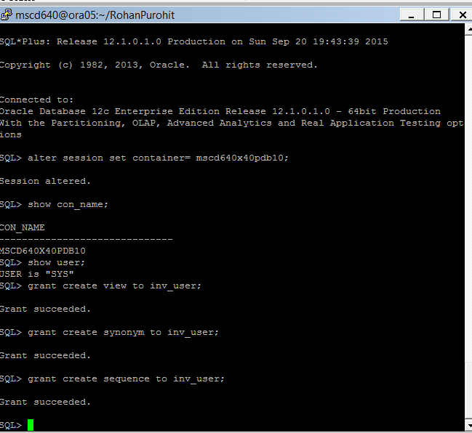
-----------------------------------------------------------------------------------

72. Create a table and an updateable view based on the table.

From your current session, connect as INV_USER in your PDB.
- Replace the xx in the PDB name with your assigned instance number.
Ex: SQL> conn inv_user/foo@msc640xpdbxx

- Create new table SALES.
Ex: SQL> create table sales(
sales_id number primary key
,amnt number
,state varchar2(2)
) tablespace users;

- Verify the table create.
Ex: SQL> desc sales;
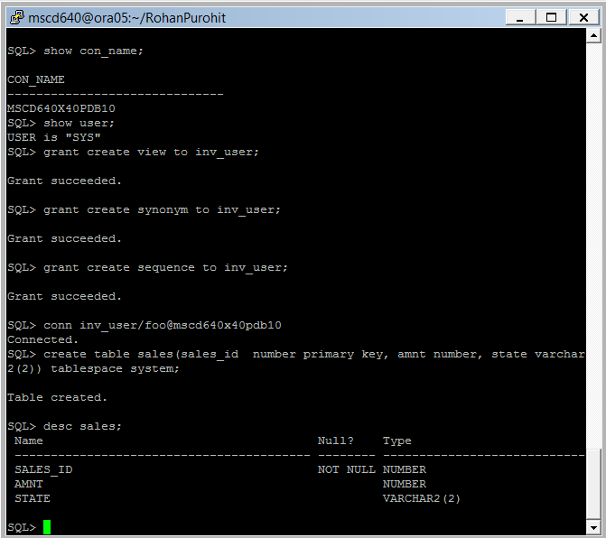
-----------------------------------------------------------------------------------

73. Create a view.
- Create a view based on table sales.
Ex; SQL> create or replace view sales_rockies as
select
sales_id
,amnt
,state
from sales
where state in ('CO','UT','WY','ID','AZ')
;

- Verify the view creation.
Ex: SQL> desc sales_rockies;
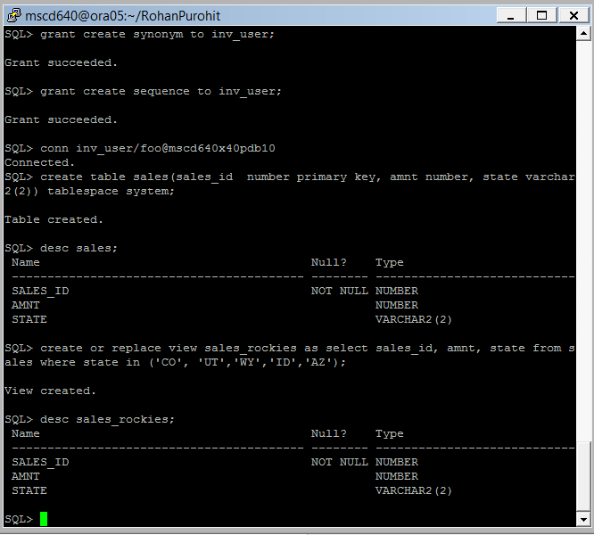
-----------------------------------------------------------------------------------
74. Experiment with inserting into the table versus the view:

- Insert one record.
Ex: SQL> insert into sales values(1,500,'CO');

- Insert a second record.
Ex: SQL> insert into sales values(2,500,'CA');

- Save your inserts.
Ex: SQL> commit;

- Review your inserts.
Ex: SQL> select * from sales;
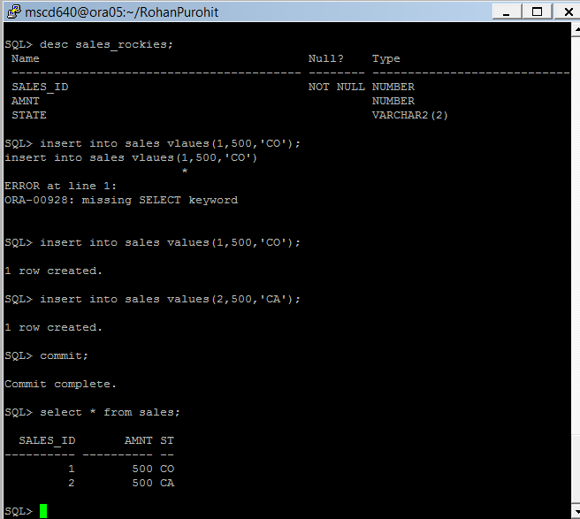
- What are the advantages to using view?
Table is a basic unit of data storage in an oracle database. It holds all user accessible data.
View is a virtual table
- It can be created on a table or another view.
- It is just like a window through which we can access or change base table data.
- It does contain data of its own. It always takes data from its base table.
- It is stored as a query in data dictionary.Whenever you query a view it gets data from its based table using this query.
Main advantage of using views
- You can ristrict access to predetermined set of rows and columns of a table
- You can hide complexity of query
- You can hide complexity of calculation

-----------------------------------------------------------------------------------
75. Is it possible to insert into a view?

- Try inserting data via your new view SALES_ROCKIES.
Ex: SQL> insert into sales_rockies(
sales_id, amnt, state)
values
(3,300,'CO');

- Select * from the view SALES_ROCKIES.
Ex: SQL> select * from sales_rockies;
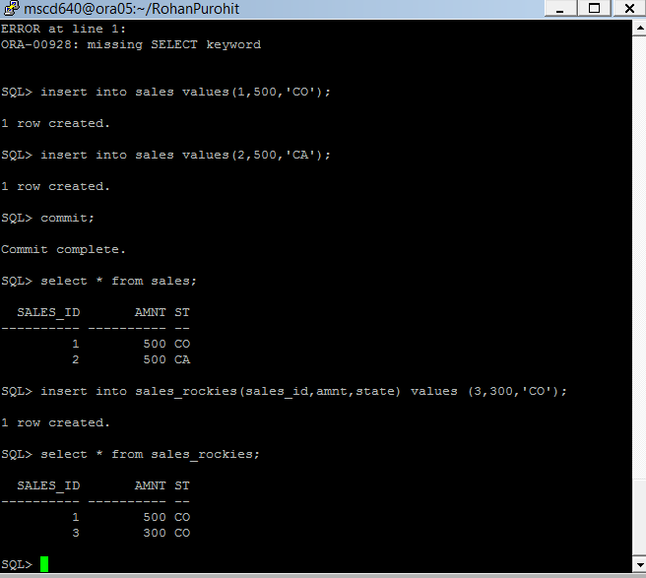
- When you insert into a view, where is the underlying data actually stored? (in what database object?)
The data is stored as a query in data dictionary.
-----------------------------------------------------------------------------------

76. Recreate the SALES_ROCKIES view with the WITH CHECK OPTION.
See pages 239-240 in the book.

- Redefine the SALES_ROCKIES view.
EX: SQL> create or replace view sales_rockies as
select
sales_id
,amnt
,state
from sales
where state in ('CO','UT','WY','ID','AZ')
with check option;

- Run the following two update statements:
SQL> update sales_rockies set state='ID' where sales_id=1;
SQL> update sales_rockies set state='CA' where sales_id=1;
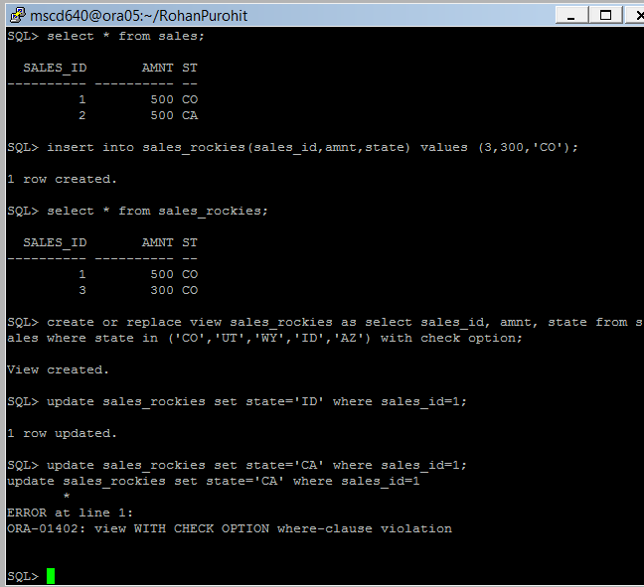
- Did an error occur? Yes an error occurred there was a where cluse violation.

- Why did the first update work but not the second one?

Because it was within limits of the where clause.
-----------------------------------------------------------------------------------

77. Recreate the view as READ ONLY.
See page 240 in the book.

- EX: SQL> create or replace view sales_rockies as
select
sales_id
,amnt
,state
from sales
where state in ('CO','UT','WY','ID','AZ')
with read only;

- Now try to update it:
Ex: SQL> update sales_rockies set state='ID' where sales_id=1;
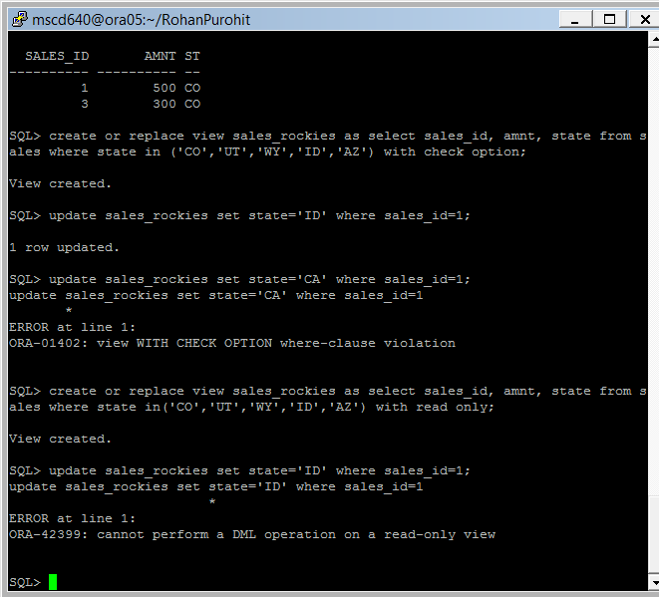
- Why did it fail? What error was returned?
We could not perform a DML operation on a read only view.
-----------------------------------------------------------------------------------
78. Generate the DDL required to recreate the view.
See pages 245-246 in the book.

- Ex: SQL> set long 5000
SQL> select dbms_metadata.get_ddl('VIEW','SALES_ROCKIES','INV_USER') from dual;
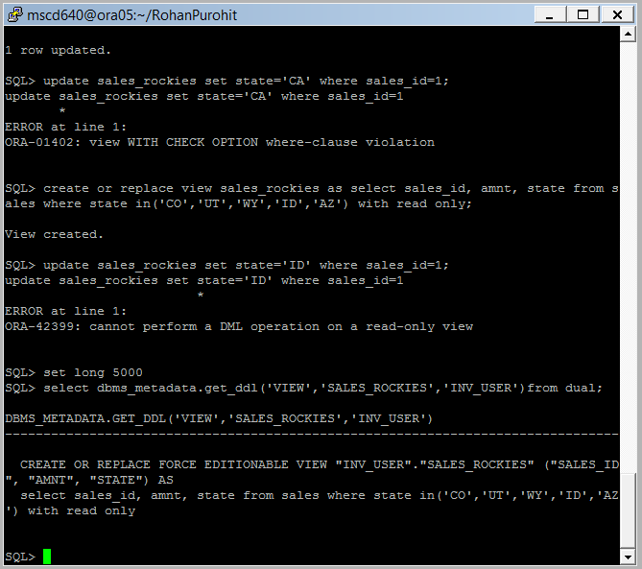
-----------------------------------------------------------------------------------

79. Create a synonym for the sales_rockies view.
See pages 247-248 in the book.

- Ex: SQL> create synonym sr_view for sales_rockies;

- Verify the synonym works:
Ex: SQL> desc sr_view
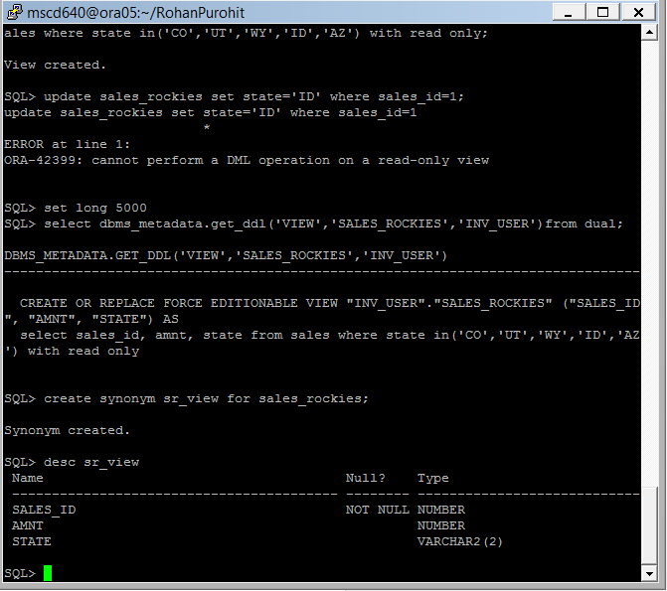
-----------------------------------------------------------------------------------
80. What is the difference between a private synonym and a public synonym?
See pages 248-249 in the book.
Some disadvantages of a public synonym include,
public synonyms pollute the namespace - there can only be one public synonym X. If two bits of your application schema want to have X - forget it. Or if you want to put two applications together in your database and they both want X. forget it.
public synonyms can lead to security issues. What if you install your application and create a public synonym X for some bit of it. Another application schema just uses "X" - believing it to be your-app.X. Then some malicious (or not even malicious, just mistaken) developer comes along and implements X in that other schema. All of a sudden, instead of calling the public synonym X - that other app will be invoking this new X.
(this is one reason why people might consider calling SYS.dbms_sql instead of dbms_sql. what if I drop a dbms_sql package into your schema surreptitiously - this dbms_sql want to be just calls sys.dbms_sql - except for the parse routine which will slighly modify your sql first. sort of like a trojan horse).
public synonyms can leads to a maintenance headache. "whoops, we did a create or replace public synonym X for y - didn't know you were using that"
public synonyms are public - no one owns them, anyone that can create them can overwrite them, change them.

-----------------------------------------------------------------------------------
81. Display synonym information contained in the data dictionary.
See pages 250 in the book.

- Ex: SQL> select
synonym_name, table_owner, table_name, db_link
from user_synonyms
order by 1;
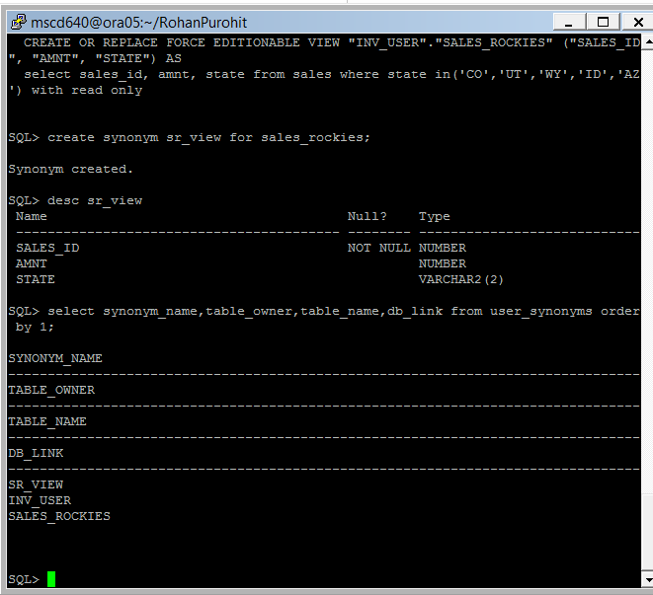
-----------------------------------------------------------------------------------

82. Create a sequence using the defaults.
See pages 251 in the book.

- Ex: SQL> create sequence inv_seq;
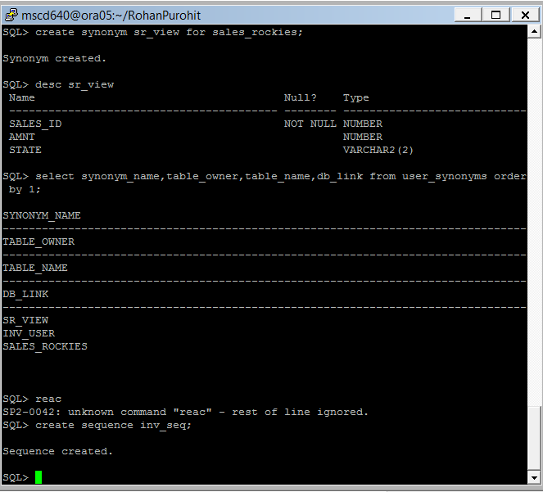
-----------------------------------------------------------------------------------

83. Create a sequence but specify some non-default values.
See pages 251-253 in the book.

- Ex: SQL> create sequence inv2_seq start with 10000 maxvalue 1000000;
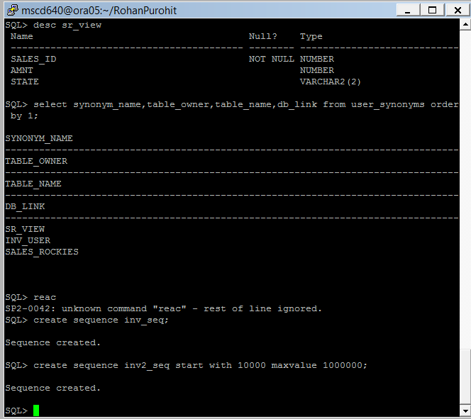
-----------------------------------------------------------------------------------
84. Use sequence pseudo column values.
See pages 252-253 in the book.

- Select the next available value from the sequence.
Ex: SQL> select inv_seq.nextval from dual;

- Select the current value of the sequence.
Ex: SQL> select inv_seq.currval from dual;
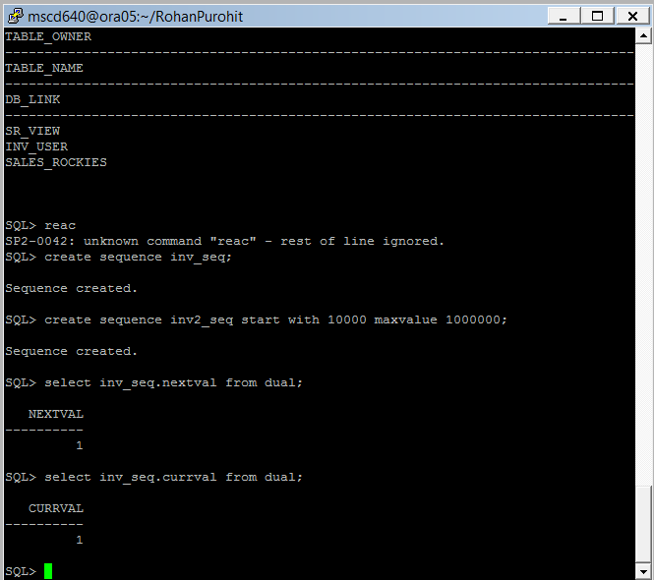
-----------------------------------------------------------------------------------
85. Verify the structure of the INV table:

- SQL> desc inv;

- Use a sequence to populate a column when inserting:
Ex: SQL> insert into inv (inv_id) values (inv_seq.nextval);

- Verify the use of your sequence
Ex: SQL> select * from inv;
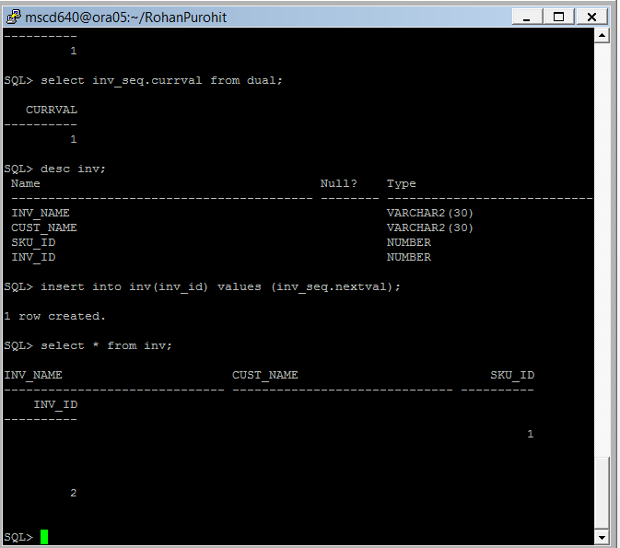
-----------------------------------------------------------------------------------
90. Display the sequence metadata.
See pages 255-256 in the book.

- Ex: SQL> select dbms_metadata.get_ddl('SEQUENCE','INV_SEQ') from dual;
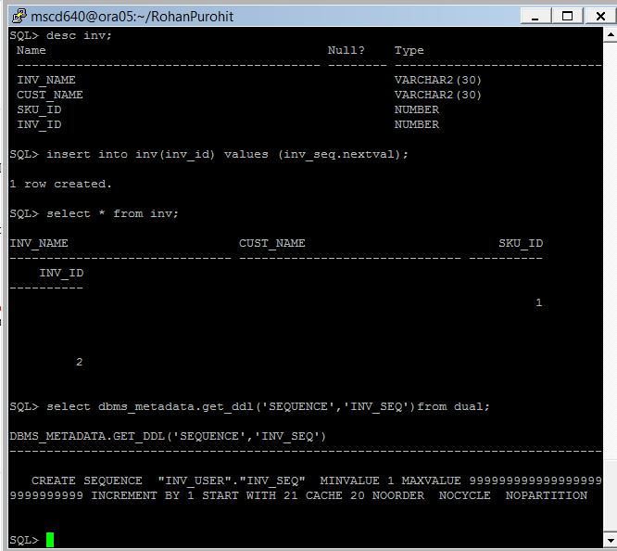
91. Close your PDB.

- From your SQL session connect as sysdba to the ROOT container.

Ex: SQL> conn / as sysdba

- Shutdown your PDB.
Replace the xx in the PDB name with your assigned instance number.
Ex: SQL> alter pluggable database msc640xpdbxx close immediate;

- Verify that your PDB is in a MOUNT state.

Enter your pluggable database name in CAPS
Ex:
SQL> select con_id, name,open_mode
from v$pdbs
where name = ‘your pluggable database name’;
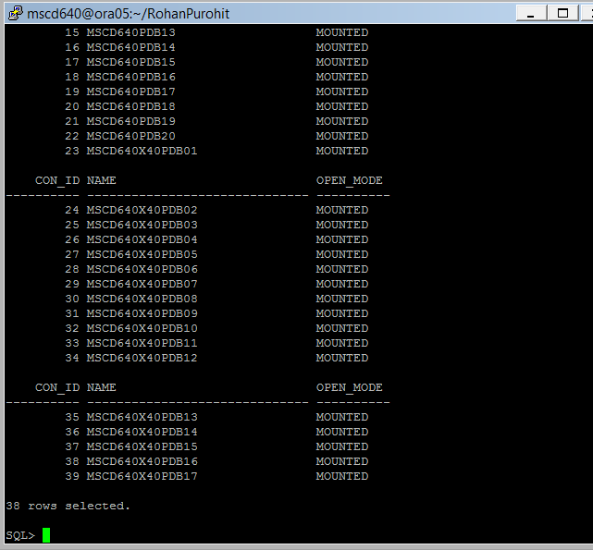
-----------------------------------------------------------------------------------
End of Lab2_PDB!

